

American International University-Bangladesh (AIUB)

**Department of Computer Science**

**Faculty of Science & Technology (FST)**

**Software Requirement Engineering**

**ONLINE LAUNDRY MANAGEMENT SYSTEM**

**Submitted by**

|  |  |  |
| --- | --- | --- |
| **Semester: Fall_23_24** | | **Section: D** |
| SN | Student Name | Student ID |
| 1 | Noshin Farzana | 21-44647-1 |
| 2 | Avijit Saha Anto | 21-44630-1 |
| 3 | Sadikul Mobasshir | 21-44415-1 |
| 4 | A B M Shoaib Ahammad | 20-44322-3 |

**Submitted To**

Prof. Dr. Kamruddin Nur

American International University-Bangladesh

**Submission Date:** 20 December 2023

**TABLE OF CONTENT**

|  |  |  |
| --- | --- | --- |
| **1.** | **PROJECT OVERVIEW** | **3-7** |
|  | **1.1 Background to the Problem** | **3** |
|  | **1.2 Solution to the Problem** | **3-4** |
|  | **1.3 Social Impact** | **5** |
|  | **1.4 Business Objective** | **5-6** |
|  | **1.5 Business Risks** | **7** |
| **2.** | **PROJECT STAKEHOLDERS** | **8** |
| **3.** | **SCOPE** | **8-9** |
| **4.** | **SCOPE REPRESENTATION TECHNIQUES (Feature Tree, Context Diagram)** | **9-10** |
| **5.** | **REQUIREMENT DESCRIPTION (System Feature, Functional Requirements, Non-Functional Requirements)** | **10-26** |
| **6.** | **REQUIREMENT PRIORITIZATION** | **27** |
| **7.** | **BUSINESS RULES** | **28-29** |
| **8.** | **UML DIAGRAM (Use Case Diagram, Class Diagram, Activity Diagram)** | **30-32** |
| **9.** | **USER STORY** | **33-38** |
| **10.** | **DATA DICTIONARY** | **38-41** |
| **11.** | **PROJECT CONSTRAINTS** | **42** |
| **12.** | **REQUIREMENT ACCEPTANCE CRITERIA** | **43-44** |
| **13.** | **REQUIREMENTS CHANGE MANAGEMENT TOOLS&PROCEDURES** | **45** |
| **14.** | **REQUIREMENT PLAN REPORT** | **46** |
| **15.** | **PROTOTYPE DESIGN** | **47-56** |
| **16.** | **SELECTION PROCESS MODEL** | **57-58** |
| **17.** | **DEVELOPMENT PLAN** | **59-61** |
| **18.** | **PROJECT SCHEDULE (CALENDER, GANTT CHART, TIMELINE TABLE)** | **62-68** |
| **19.** | **MARKETING PLAN** | **69-70** |
| **20.** | **COST & PROFIT ANALYSIS** | **71-74** |
| **21.** | **OPERATING ENVIRONMENT** | **75-76** |
| **22.** | **TEST CASE DESIGN** | **77-88** |
| **23.** | **RISK ANALYSIS** | **89** |
| **24.** | **PROJECT CLIENT ACCEPTANCE & SIGN-OFF FORM** | **90** |
| **25.** | **REFERENCES** | **91** |

**Online Laundry Management System**

1. **PROJECT OVERVIEW**

### Background to the Problem

* The background to the problem for online laundry services is related to the increasing demand for a convenient and time-saving solution for people who lead busy lives and do not have the time or energy to do their own laundry. Laundry is an essential part of our daily life, and many people do not have the time or resources to do it themselves. The traditional laundry services can be inconvenient as customers need to travel to a physical location to drop off and pick up their laundry, which can be time-consuming and inconvenient. They need a reliable and efficient solution to handle their laundry needs, and with the increasing use of technology, they are looking for an online laundry service that can offer them convenience and quality service.
* However, the current laundry service industry is fragmented, and customers have limited options to choose. They may not know which service providers are trustworthy and which ones can provide quality service. Also, there is a lack of transparency in pricing and service quality, making it challenging for customers to make informed decisions. Therefore, there is a need for an online laundry service platform that can offer customers a wide range of options, transparent pricing, and a seamless user experience.

### Solution to the Problem

* To solve the challenges faced by customers in the laundry service industry, our Online Laundry Management System allows Customers to search for their preferred laundry service providers. The system can offer both web and app-based solutions, making it accessible to a wide range of Customers. Customers can search for their preferred laundry brands or local laundry service providers, filter their searches based on location and service type, and select the one that best meets their needs. The platform can also offer Customers a map view of the available laundry service providers and their locations, making it easier for them to choose one near their location.
* One of the key features of our Online Laundry Management System is the ability for Customers to schedule their laundry pickups and deliveries online, eliminating the need to travel to a physical location. Customers can simply specify the date and time they want their laundry to be picked up and a Delivery Person will come to their location to collect them. Similarly, Customers can specify the date and time they want their laundry to be delivered, and the cleaned laundry will be delivered to their doorstep.
* When a Customer places an order, a notification is sent to the Laundry Company. Laundry Company informs the Office Employee about the order and the Office Employee assigns a Delivery Person who will go to the Customer’s location to collect the laundry. Then the Delivery Person gives it to the Laundry Company. When the clothes are washed, the Laundry Company informs the Office Employee. Then the Office Employee again assigns a Delivery Person to pick up the cleaned clothes from Laundry Company. The Delivery Person picks it up and delivers it to the Customer.
* To enhance the Customer experience, our Online Laundry Management System will also provide real- time tracking of laundry pickups and deliveries. Customers will be able to track the status of their laundry from pickup to delivery, ensuring that they are always aware of the progress of their laundry. This will give Customers peace of mind and ensure that they can plan their schedules accordingly.

* To ensure quality service, the platform can offer a rating and review system for laundry service providers. This system will enable Customers to rate their experience and provide feedback on the service quality, pricing, and overall customer experience. It will also help build trust and transparency in the industry by providing Customers with a better understanding of the quality of service offered by different providers.
* Our Online Laundry Management System will also offer transparent pricing and payment options, allowing Customers to see the cost of different laundry services upfront and choose the one that fits their budget. The platform can accept secure online payments, making it convenient for Customers to pay for the service without worrying about cash handling.
* Our Online Laundry Management System will offer Customers a convenient and reliable solution to their laundry needs. It can provide Customers with a wide range of options, transparent pricing, and a seamless user experience. This will help improve the quality of service and increase Customer satisfaction, thereby promoting the growth of the laundry service industry.
* The existing software solutions that are available to solve the problem are laundry management system, Elaundry (https://www.elaundry.com.bd), Dhopaghat (https://www.dhopaghat.com), Hello Laundry (http://hellolaundry.com.bd) etc. The current system lacks a real-time map, sophisticated security, and an online database. On the other side, our Online Laundry Management System includes these qualities.

**1.3 Social impact:**

We are currently working on a project named ONLINE LAUNDRY MANAGEMENT SYSTEM. The adoption of this system can benefit society in a number of ways. The most important advantage is better hygiene. A laundry management system can improve public health by ensuring that clothing and linens are cleaned and dried at the proper temperatures and with the necessary detergents. This is done through preventing the transmission of illnesses and infections. A laundry management system can also help people, families, and businesses save time by automating the collection, washing, drying, and folding of garments. This could make time available for other pursuits including job, education, and socializing. Moreover, it can also contribute to waste reduction by optimizing water and energy use, which will enhance productivity and have a favorable effect on the environment. In addition to opening up new career paths for technicians, operators, and maintenance personnel, the introduction of a laundry management system can also assist boost economic growth and lower unemployment rates. It can increase access to laundry services for those who might not have access to a washer or dryer, such as those who reside in small apartments or the homeless. Overall, the implementation of a laundry management system can significantly improve hygiene, save time, increase efficiency, create jobs, and increase accessibility to laundry services for a larger range of individuals.

### Business Objective

**BO-1:** Increase the operational efficiency of the Online Laundry Management System to reduce the cost of unprocessed laundry items by 30% within the first 6 months after the launch.

* **Scale:** Cost of unprocessed laundry items per week
* **Meter:** Analysis of order fulfillment logs and inventory tracking system
* **Past**: N/A (as this is a new service)
* **Goal:** Less than 30%
* **Stretch:** Less than 25%

**BO-2:** Achieve a 20% reduction in overall operating costs for the business within 12 months after the initial launch.

* **Scale:** Total operating costs per month
* **Meter:** Financial analysis of monthly expenses and revenue
* **Past:** N/A (as this is a new service)
* **Goal:** Less than 20%
* **Stretch:** Less than 15%

**BO-3:** Enhance customer satisfaction by ensuring a 95% on-time delivery rate for laundry services, contributing to an increase in average effective work time for customers by 20 minutes within 6 months of the initial release.

* + **Scale:** On-time delivery rate
  + **Meter:** Customer feedback and delivery tracking system
  + **Past:** N/A (as this is a new service)
  + **Goal:** 95% on-time delivery
  + **Stretch:** 98% on-time delivery

### Business Risks

This table provides a concise overview of each business risk, including its description, probability, and impact-

| **Risk ID** | **Risk Description** | **Probability** | **Impact** |
| --- | --- | --- | --- |
| RI-1 | The Laundry Service Providers Union might require that their contract be renegotiated to reflect the new employee roles and laundry service hours of operation. | 0.6 | 3 |
| RI-2 | Too few customers might use the system, reducing the return on investment from the system development and the changes in laundry service operating procedures. | 0.3 | 9 |
| RI-3 | Local laundry service providers might not agree to participate in the system, which would reduce customer satisfaction with the system and possibly their usage of it. | 0.3 | 3 |
| RI-4 | Sufficient delivery capacity might not be available, which means that customers might not always receive their laundry on time and could not always request delivery for the desired times. | 0.5 | 6 |

1. **PROJECT STAKEHOLDERS**

* **Customers:** These are the end-users who use the system to schedule laundry services, make payments, and track the status of their orders.
* **Laundry Service Providers:** These are the businesses or individuals offering laundry services. They use the system to receive and manage orders, schedule pickups and deliveries, and track inventory.
* **Administrators:** System administrators are responsible for managing and maintaining the Online Laundry Management System. They handle user accounts, permissions, and system configuration.
* **Delivery Personnel:** They use the system to receive order details, update order statuses, and optimize delivery routes.
* **Project Manager:** Project Planning, Stakeholder Management, Requirements Analysis, Team Management, Risk Management, Budget Management, Timeline Management.
* **Billing and Finance Department:** This team is responsible for handling payments, invoices, and financial transactions related to the laundry services.
* **Customer Support:** The customer support team uses the system to assist customers with inquiries, resolve issues, and manage customer feedback and complaints.
* **Marketing and Sales:** The marketing and sales department may use the system to analyze customer data, target specific demographics, and run promotional campaigns.
* **Security and IT Personnel:** These individuals are responsible for the security and maintenance of the system, ensuring that it is protected against data breaches and technical issues.
* **Business Owners/Management:** The owners and top-level management of the laundry service have a vested interest in the system's performance, profitability, and overall success.
* **Mobile App Developers/Website Developers:** The developers responsible for maintaining and updating these platforms are important stakeholders.

1. **SCOPE:**

* **User Management:** The software has user management capabilities to handle the roles and permissions of different users.
* **Customer Management:** The system should allow for the management of customer information, including contact details, order history, and preferences.
* **Order Management:** Customers should be able to place orders for laundry services online, specify the type of service, pickup and delivery details, and track the status of their orders.
* **Scheduling and Routing:** Efficiently schedule pickups and deliveries of laundry orders, optimizing routes to save time and resources. This also includes real-time tracking of delivery personnel.
* **Billing and Invoicing:** Generating invoices for customers, processing payments online, and keeping track of financial transactions.
* **Reporting and Analytics:** Providing detailed reports and analytics to help the management make informed decisions, tracking key performance indicators, and monitoring the success of the online platform.
* **Notifications and Alerts:** Sending automated notifications to customers about order status, pickup and delivery times, and other important updates through email, SMS, or mobile apps.
* **Employee Management:** Managing staff schedules, assigning tasks, and tracking the performance of employees responsible for online laundry operations. This also includes online training and performance tracking tools.
* **Customer Communication:** Providing communication channels for customers to ask questions, request support, or provide feedback through the online platform, chat support, or email.
* **Mobile Accessibility:** Ensuring the software is accessible through mobile apps or responsive web design, allowing customers to place orders and access their accounts from smartphones or tablets.
* **Integration with Other Systems:** Integrating the online laundry management software with accounting software and other tools used in the laundry business for a seamless online workflow. It also involves integration with GPS systems for tracking and route optimization.
* **Security and Data Protection:** Implementing robust security measures to protect customer and business data, including encryption, secure authentication, and secure data storage.
* **Compliance:** Ensuring the software complies with relevant online security and data protection regulations and standards.
* **Website and Mobile App Development:** The project requires the development of a user-friendly website and mobile applications for both customers and employees.

1. **SCOPE REPRESENTATION TECHNIQUES**

**Feature Tree**

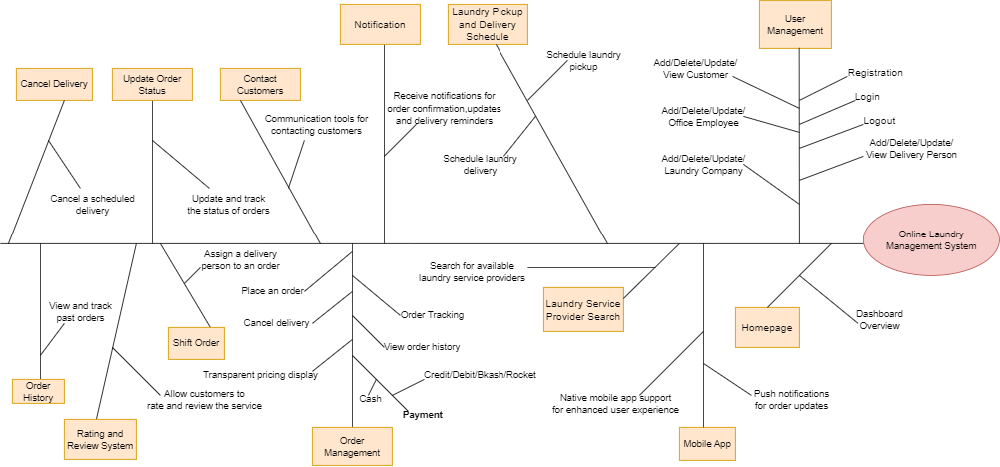

**Context Diagram**

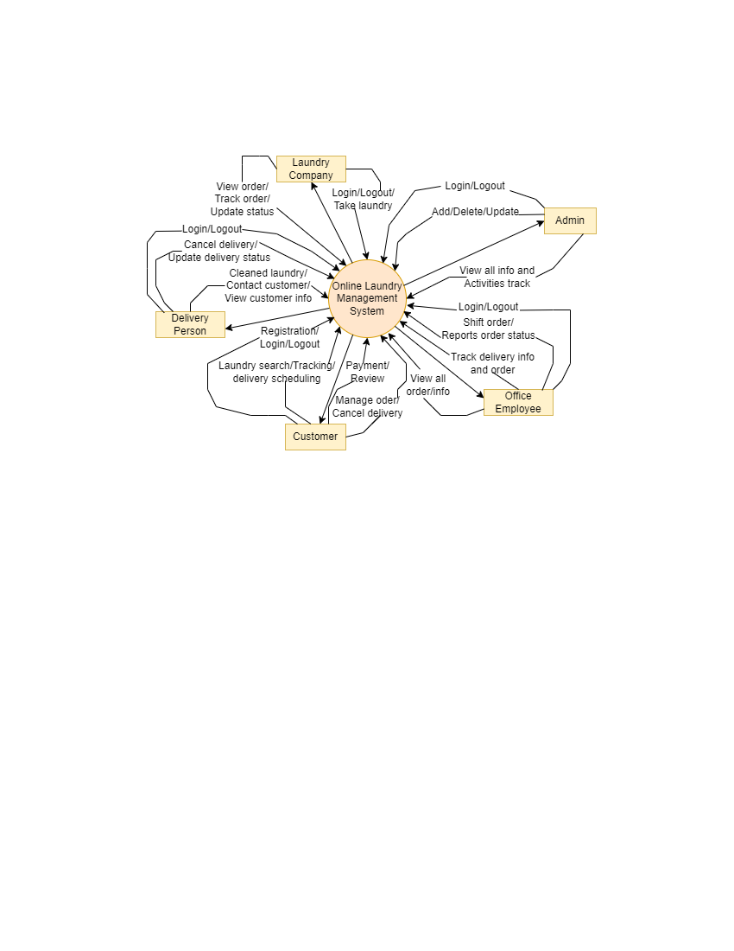

1. **REQUIREMENT DESCRIPTION**

**System Features**

* **Common Features**
* **System Feature: Home Page**

**Functional Requirements:**

* The home page should provide users with an overview of the laundry service.
* The home page should allow users to navigate to different sections of the website.
* The home page should include a search function that allows users to find laundry service providers by location.
* The home page should display the most popular laundry service providers or promotions.
* The home page should allow users to register or sign into their account.
* The home page should display information about the laundry service, such as pricing, delivery options, and payment methods.

**Non-Functional Requirements:**

* **Usability:** The home page should be easy to navigate and provide users with the information they need quickly and efficiently.
* **Reliability:** The home page should be always stable and available to users.
* **Performance:** The home page should load quickly and respond to user actions promptly.
* **Security:** The home page should protect user data and ensure the privacy and security of sensitive information.
* **Accessibility:** The home page should be accessible to users with disabilities, including those who use assistive technology.
* **Scalability:** The home page should be able to handle a large number of users and display information in real-time.
* **System Feature: Login**

**Functional Requirements:**

* Allow users (Admin, Office-Employee, Delivery Personnel, Laundry Company, Customer) to log in to their account using their email address or username and password or social media credentials.
* For login to the system database records will be compared with the username and password.
* If the login is successful, the homepage will be shown.
* The system will randomly generate a verification code and send it to the user's email address to try again if the entered username and password are incorrect.
* If a user attempts to login more than three times, the system will display "Forgot Password?"
* Anyone who selects the "Forgot Password" option will see a page where they must enter their mailing address. The user's mailbox will receive a verification code.
* The user will be able to change the password once they have entered the verification code. The user will then be automatically logged in and the home page will appear.
* If the user is new, they will click for register option, and it will take user to the register page.

**Non-Functional Requirements:**

* **Usability:** The login system must be user-friendly and easy to navigate for users of all technical backgrounds.
* **Security:** The login system must ensure the confidentiality and integrity of user credentials and prevent unauthorized access to user accounts.
* **Performance:** The login system must be fast and responsive to provide a seamless user experience.
* **Accessibility:** The login system must be accessible to users with disabilities or special needs.
* **Admin**

## System Feature: ADD (Office Employee, Delivery Personnel, Laundry Company, Add Branch of different Laundry Company)

**Functional Requirements:**

* The system should allow authorized users (Admin) to add new Office Employees, Delivery Personnel, and Laundry Companies to the system.
* The system should provide a user-friendly interface for entering and saving information about newly added Employees and Companies.
* The system should allow the addition of different branches for each Laundry Company, along with their location details.

**Non-Functional Requirements:**

* **Usability:** The system should have an intuitive and easy-to-use interface for adding new entities to the system, reducing the chances of user errors.
* **Reliability:** The system should ensure that all newly added entities are correctly saved and available for future use.
* **Security:** The system should have appropriate access controls to ensure that only authorized users can add new entities to the system.
* **Scalability:** The system should be able to handle a large number of concurrent requests for adding new entities to the system without compromising its performance.

## System Feature: DELETE (Office Employee, Delivery Personnel, Laundry Company)

**Functional Requirements:**

* The system should allow authorized users (Admin) to delete Office Employees, Delivery Personnel, and Laundry Companies from the system.
* The system should prompt the user to confirm the deletion action before removing any entity from the system.
* The system should ensure that deleting an entity will not cause data inconsistencies in the system.

**Non-Functional Requirements:**

* **Usability:** The system should have a clear and easy-to-use interface for deleting entities from the system, reducing the chances of user errors.
* **Reliability:** The system should ensure that all deleted entities are correctly removed from the system and will not cause any data inconsistencies.
* **Security:** The system should have appropriate access controls to ensure that only authorized users can delete entities from the system.
* **Scalability:** The system should be able to handle a large number of concurrent requests for deleting entities from the system without compromising its performance.

## System Feature: VIEW (All information of Customer, Office Employee, Delivery personnel, Laundry Company)

**Functional Requirements:**

* The system should allow authorized users (Admin) to view all information about Customers, Office Employees, Delivery Personnel, and Laundry Companies stored in the system.
* The system should provide a user-friendly interface for displaying the requested information to the user.
* The system should allow the user to filter and sort the displayed information based on various criteria.

**Non-Functional Requirements:**

* **Usability:** The system should have an intuitive and easy-to-use interface for displaying information to the user, reducing the chances of user errors.
* **Reliability:** The system should ensure that all information displayed to the user is accurate and up to date.
* **Security:** The system should have appropriate access controls to ensure that only authorized users can view the requested information.
* **Scalability:** The system should be able to handle a large number of concurrent requests for displaying information to the user without compromising its performance.

## System Feature: UPDATE (All information of Customer, Office Employee, Delivery Personnel, Laundry Company)

**Functional Requirements:**

* The system should allow authorized users to update all information about Customers, Office Employees, Delivery Personnel, and Laundry Companies stored in the system.
* The system should provide a user-friendly interface for modifying the existing information and saving the changes to the system.
* The system should ensure that updating an entity will not cause data inconsistencies in the system.

**Non-Functional Requirements:**

* **Usability:** The system should have an intuitive and easy-to-use interface for updating information, reducing the chances of user errors.
* **Reliability:** The system should ensure that all updated information is correctly saved and available for future use.
* **Security:** The system should have appropriate access controls to ensure that only authorized users can update information in the system.
* **Scalability:** The system should be able to handle a large number of concurrent requests for updating information without compromising its performance.

## System Feature: Activity track

## Functional Requirements:

* The system should be able to track all Office-Employee’s activities.
* The system should be able to track the location of Delivery Person in real-time.
* The system should be able to track the status of Customer orders, from pickup to delivery.
* The system should be able to generate reports on Employee productivity and order fulfillment.

## Non-Functional Requirements:

* **Usability:** The tracking function should be easy to use with clear instructions and an intuitive interface.
* **Reliability:** The tracking function should provide accurate and up-to-date information on Employee location and order status.
* **Performance:** The tracking function should be fast and efficient, with minimal loading times for tracking information and notifications.
* **Security:** The tracking function should ensure the privacy and security of Customer and Employee data.
* **Scalability:** The tracking function should be able to handle a large number of tracking requests and provide information in real-time.

* **Office Employee:**

## System Feature: View Order from Customer and see selected Laundry Company

**Functional Requirements:**

* The system should allow the Office Employee to view all orders placed by Customers.
* The system should display details of each order, such as the Customer’s name, contact information, delivery address, and order status.
* The system should allow the Office Employee to filter and sort orders based on various criteria, such as delivery date, order status, and Customer name.
* The system should allow the Office Employee to view orders placed in different laundry service providers.
* The system should display details of each order, such as the laundry service provider name, contact information, and order status.
* The system should allow the Office employee to filter and sort orders based on various criteria, such as delivery date, order status, and laundry service provider name.

**Non-Functional Requirements:**

* **Usability:** The system should provide an easy-to-use interface for viewing and managing orders.
* **Reliability:** The system should display accurate and up-to-date information about each order and its status.
* **Performance:** The system should be fast and efficient, with minimal loading times for order details and search results.
* **Security:** The system should ensure the privacy and security of customer and laundry service provider data.
* **Scalability:** The system should be able to handle a large number of orders and display order details in real-time.

## System Feature: Shift Order (Assign Delivery Person to take laundry from Customer and give it to the Laundry Company)

## Functional Requirements:

## The system should allow the Office Employee to access the list of pending orders.

* The system should allow the Office Employee to assign a pending order to a designated Delivery Person provided by the Customer.
* The system should allow the Office Employee to view the status of assigned orders and update their status as necessary.
* The system should allow the Office Employee to communicate with the assigned Delivery Person regarding any issues or changes to the order.
* The system should allow the Office Employee to generate reports on the order delivery status.

**Non-Functional Requirements:**

* **Usability:** The system should be easy to use and navigate for the Office Employee, with clear instructions on how to assign and track orders.
* **Reliability:** The system should be reliable and accurate, with up-to-date information on the status of orders and the availability of Delivery Personnel.
* **Performance:** The system should be fast and efficient, with minimal loading times for order details and status updates.
* **Security:** The system should ensure the privacy and security of Customer information and order details.
* **Scalability:** The system should be able to handle a large number of orders and Delivery Personnel, with the ability to assign and track orders in real-time.

## System Feature: Shift Order (Assign Delivery Person to take back cleaned laundry from the Laundry Company and deliver it to the Customer)

**Functional Requirements:**

* The system should allow the Office Employee to receive cleaned laundry delivery requests from Laundry Companies.
* The system should provide the necessary information about the delivery, including Customer details, delivery location, and laundry items.
* The system should allow the Office Employee to assign the delivery to a specific Delivery Person to take back cleaned laundry from the Laundry Company and deliver it to the Customer.
* The system should provide a notification to the assigned Delivery Person about the delivery details and location.
* The system should allow the Office Employee to track the Delivery person's location and estimated time of arrival.
* The system should allow the Office Employee to update the delivery status and notify the Laundry Company and Customer about any changes.

**Non-Functional Requirements:**

* **Usability:** The shift order function should be easy to use and navigate for the Office Employee.
* **Reliability:** The system should ensure that delivery requests are accurate and complete and that the assigned Delivery Person is reliable and responsible.
* **Performance:** The system should be fast and efficient in processing delivery requests and assigning Delivery Persons.
* **Security:** The system should ensure the privacy and security of Customer and Delivery Person data and information.
* **Scalability:** The system should be able to handle a large volume of delivery requests and assign Delivery Person in real-time.

## System Feature: Track Order

**Functional Requirements:**

* The system should allow Office Employees to track the status of laundry orders.
* The system should display real-time updates on the progress of laundry orders, including pickup, delivery, and any delays.
* The system should allow Office Employees to view the location of Delivery Personnel and the estimated time of delivery.
* The system should provide Office Employees with notifications of any issues or delays with orders.
* The system should allow Office Employees to update the status of orders as they are processed.

**Non-Functional Requirements:**

* **Reliability:** The system should provide accurate and up-to-date information on the status of laundry orders.
* **Usability:** The tracking function should be easy to use and provide relevant and timely information to office employees.
* **Performance:** The tracking function should be fast and efficient, with minimal loading times for updates and notifications.
* **Security:** The system should ensure the privacy and security of order and Customer data.
* **Scalability:** The system should be able to handle a large number of tracking requests and updates in real-time.

* **Delivery Person:**

## System Feature: View Assigned Deliveries

**Functional Requirements:**

* The system should allow the Delivery Person to view their assigned deliveries.
* The Delivery Person should be able to see the details of the delivery, such as the Customer's address, contact information, and order details.
* The system should display the delivery route on a map to help the Delivery Person navigate to each Customer's location efficiently.
* The Delivery Person should be able to mark each delivery as completed once it has been delivered to the Customer.
* The system should update the status of the Delivery in real-time, so the Office Employee can track the progress of the deliveries.

**Non- Functional Requirements:**

* **Usability:** The interface for viewing assigned deliveries should be intuitive and easy to use for the Delivery Person.
* **Reliability:** The system should provide accurate and up-to-date information on assigned deliveries and their status.
* **Performance:** The system should be fast and efficient in displaying the delivery route and updating the delivery status.
* **Security:** The system should ensure the privacy and security of Customer and Delivery Person data.
* **Scalability:** The system should be able to handle a large number of deliveries and display real-time updates for each delivery.

## System Feature: Update Delivery Status

**Functional Requirements:**

* The system should allow the Delivery Person to update the status of the delivery, such as "en route", "delivered", or "failed to deliver".
* The system should notify the Customer of any updates to their delivery status in real-time.
* The system should allow the Office Employee to view the updated delivery status and take appropriate actions if necessary.
* The system should keep a record of all delivery status updates for future reference and analysis.

**Non-Functional Requirements:**

* **Usability:** The update delivery status function should be easy to use and require minimal effort from the delivery person.
* **Reliability:** The system should ensure that the updated delivery status is accurate and reflected in real-time for the customer and office employee.
* **Performance:** The update delivery status function should be fast and efficient, with minimal loading times.
* **Security:** The system should ensure the privacy and security of Customer data and delivery information.
* **Scalability:** The system should be able to handle a large number of delivery status updates in real-time.

## System Feature: Cancel Delivery Notification

**Functional Requirements:**

* The system should allow the Customer or the Office Employee to cancel a delivery.
* The cancellation request should be processed in real-time.
* The system should notify the relevant parties (e.g., the Delivery Person, the Customer, and the Laundry Company) of the cancellation.
* The system should update the delivery status to "Cancelled" in the database.
* The system should process any refunds or charges associated with the cancellation according to the company's policies.

**Non-Functional Requirements:**

* **Reliability:** The cancellation process should be reliable and not result in errors or system crashes.
* **Usability:** The cancellation process should be easy to use and accessible to both Customers and Office employees.
* **Security:** The system should ensure the privacy and security of user data, including payment information and order history.
* **Scalability:** The system should be able to handle a large volume of cancellation requests without slowing down or crashing.

## System Feature: View Customer Information

**Functional Requirements:**

* The system should allow the Delivery Person to view Customer information such as name, address, and contact number.
* The system should only display Customer information for the delivery that is assigned to the Delivery Person.
* The system should ensure the privacy and security of Customer data and prevent unauthorized access.

**Non-Functional Requirements:**

* **Security:** The system should have strong access controls and prevent unauthorized access to Customer data.
* **Privacy:** The system should protect Customer data and only allow access to authorized Delivery persons.
* **Usability:** The system should provide an easy-to-use interface for Delivery Person to view Customer information.
* **Reliability:** The system should provide accurate and up-to-date Customer information to the Delivery person.

## System Feature: Contact Customer

**Functional Requirements:**

* The system should allow the Delivery Person to view the contact information of the Customer for a particular delivery order.
* The system should provide the option for the Delivery Person to contact the Customer via phone or message directly from the system.
* The system should track all communication between the Delivery Person and the Customer for record-keeping purposes.

**Non-Functional Requirements:**

* **Usability**: The contact feature should be easily accessible and straightforward for the Delivery Person to use.
* **Reliability:** The system should provide accurate and up-to-date contact information for the customer.
* **Security:** The system should ensure the privacy and security of Customer data, including their contact information.
* **Scalability:** The system should be able to handle a large volume of communication requests between Delivery Person and Customers.

* **Laundry Company:**

## System Feature: View Upcoming Orders

**Functional Requirements:**

* The system should allow the laundry company to view a list of upcoming orders that are scheduled to be delivered by a specific Delivery Person and provided by Office Employee.
* The system should display relevant details about each upcoming order, such as the Customer's name, order details, and delivery address.
* The system should allow the laundry company to filter and sort the list of upcoming orders based on various criteria such as date, time, order status, and Delivery Person.
* The system should allow the laundry company to update the status of each upcoming order, such as "processing," "ready for delivery," "out for delivery," and "delivered."
* The system should provide real-time updates to the laundry company and the Delivery Person regarding any changes in the status of an upcoming order.

**Non-Functional Requirements:**

* **Usability:** The view function should be easy to use and provide relevant and accurate information to the laundry company.
* **Reliability:** The system should provide accurate and up-to-date information on upcoming orders and their delivery status.
* **Performance:** The view function should be fast and efficient, with minimal loading times for the list of upcoming orders and the order details.
* **Security:** The system should ensure the privacy and security of customer data and order information.
* **Scalability:** The system should be able to handle a large number of upcoming orders and display them in real-time.

## System Feature: Take order (laundry) from Delivery Person

**Functional Requirements:**

* The system should allow Delivery Person to input and submit orders (laundry) to the laundry company.
* The system should allow laundry company to view and manage the orders received from Delivery persons.
* The system should enable the laundry company to track and update the status of the orders.
* The system should provide a notification to the Delivery Person upon the acceptance of their order.
* The system should allow the Delivery Person to view the status of their submitted orders.

**Non-Functional Requirements:**

* **Usability:** The system should be easy to use for both Delivery Person and laundry company.
* **Reliability:** The system should accurately record and manage the orders received from Delivery Person.
* **Performance:** The system should be fast and efficient, with minimal lag times between order submission and acceptance.
* **Security:** The system should ensure the privacy and security of all order information and transaction details.
* **Scalability:** The system should be able to handle a large volume of orders from multiple Delivery Person simultaneously.

## System Feature: Update Order Status for Laundry Company

**Functional Requirements:**

* The system should allow the laundry company to update the status of an order after taking the product (laundry) from the Delivery Person.
* The system should present the Office Employee with a list of Delivery Person who are available to fulfill the order, from which they can choose. Additionally, the company must ensure that the selected Delivery person receives the product for delivery.
* The system should allow the company to update the status of an order after shifting the product to the Delivery Person again.
* The system should provide an option to select the current status of the order from a predefined list of statuses.
* The system should send notifications to the Delivery Person and the Customer about the status update.

**Non-Functional Requirements:**

* **Usability:** The status update function should be easy to use and provide relevant and accurate information to the company, the Delivery Person, and the Customer.
* **Reliability:** The system should ensure that the status updates are accurate and up-to-date.
* **Performance:** The status update function should be fast and efficient, with minimal loading times for the status updates and notifications.
* **Security:** The system should ensure the privacy and security of user data, including order information.
* **Scalability:** The system should be able to handle a large number of status updates and notifications in real-time.
* **Customer:**

## System Feature: User Registration

**Functional Requirement:**

* Users must register to log in to the system.
* In this registration process the user must provide country code, mobile number & email address.
  + Basic information form will be filled by user.
    - In this form the user needs to provide his/her name.
    - Users should set a password for further login.
    - Also, they have to provide date of birth, gender.
    - User must include his/her photo.
* After giving all the information, the user needs to click the submit button.
  + - User will submit the code which has sent via email or phone number.
  + After that the user will be successfully registered to the system.

**Non-Functional Requirement:**

* **Security:** The system must ensure that the user's personal information is protected and not accessible to unauthorized users.
* **Usability:** The registration process should be simple and easy to use for the users.
* **Performance:** The system should be able to handle a large number of user registrations simultaneously.

* **System Feature:** Laundry Service Provider Search

**Functional Requirement:**

* Allow users to search for laundry service provider company based on their location and service type.

**Non-Functional Requirement:**

* **Accuracy:** The search results should be accurate and match the user's search criteria.
* **Performance:** The system should be able to retrieve the search results quickly and efficiently.
* **Usability:** The search interface should be easy to use and navigate.

## System Feature: Laundry Pickup and Delivery Scheduling

**Functional Requirement:**

* Allow users to schedule their laundry pickups and deliveries online.

**Non-Functional Requirement:**

* **Reliability:** The system should ensure that the laundry is picked up and delivered on the specified date and time.
* **Usability:** The scheduling process should be simple and easy to use for the users.
* **Performance:** The system should be able to handle a large number of laundry pickup and delivery requests simultaneously.

## System Feature: Laundry Tracking

**Functional Requirement:**

* Allow users to track the status of their laundry from pickup to delivery.

**Non-Functional Requirement:**

* **Accuracy:** The tracking information should be accurate and up-to-date.
* **Usability:** The tracking interface should be easy to use and navigate.
* **Performance:** The system should be able to retrieve the tracking information quickly and efficiently.

## System Feature: Rating and Review System

**Functional Requirement:**

* Allow users to rate and review laundry service providers based on their experience.

**Non-Functional Requirement:**

* **Accuracy:** The rating and review system should accurately reflect the user's experience with the laundry service provider.
* **Usability:** The rating and review interface should be easy to use and navigate.
* **Security:** The rating and review system should be protected from fraudulent reviews and ratings.

## System Feature: Transparent Pricing and Payment Options

**Functional Requirement:**

* Display transparent pricing information for laundry services and provide secure online payment options.

**Non-Functional Requirement:**

* **Accuracy:** The pricing information displayed should accurately reflect the actual cost of the laundry service.
* **Security:** The online payment system should be secure and protected from fraudulent activities.
* **Usability:** The payment process should be simple and easy to use for the users.

## System Feature: Order Management System Feature

**Functional Requirements:**

* Allow users to place an order for laundry services by selecting the type of service, laundry items, and quantity.
* Allow users to specify the pickup and delivery time and location.
* Allow users to track the status of their order and receive notifications regarding the pickup, delivery, and completion of the order.
* Provide an option for users to cancel or modify their order before pickup.
* Ensure that the order details and user information are secure and protected.

**Non-Functional Requirements:**

* **Reliability:** The system must ensure that all orders are accurately processed and fulfilled on time.
* **Performance:** The system must be able to handle a large number of orders and users simultaneously without any delay or lag.
* **Availability:** The system must be available 24/7 to accept and process orders.
* **Security**: The system must ensure the confidentiality, integrity, and availability of user data and transaction information.

## System Feature: Order Tracking

**Functional Requirements:**

* Provide Customers with the ability to track the status of their laundry orders in real-time.
* Allow Customers to view detailed information about their order, such as the estimated delivery/pickup time, the status of each item in the order, and any special instructions or notes from the laundry service provider.
* Send notifications to Customers when their order status changes, such as when the laundry

is picked up, when it is being washed, when it is ready for delivery, and when it has been delivered.

* Allow Customers to view a history of their previous orders and their corresponding order statuses.

**Non-Functional Requirements:**

* **Reliability:** The order tracking system should be reliable and accurate, providing customers with up-to-date and correct information about their orders.
* **Usability:** The order tracking system should be easy to use and navigate, with clear and intuitive interfaces that allow customers to quickly find the information they need.
* **Performance:** The order tracking system should be fast and responsive, with minimal delay in updating the order status or sending notifications to Customers.
* **Security:** The order tracking system should be secure and protect Customers' personal and order information from unauthorized access or data breaches.

1. **REQUIREMENT PRIORITIZATION**

|  |
| --- |
| **Requirements Prioritization using MoSCoW Rules** |

|  |  |
| --- | --- |
| **Must have** | * Login * Logout * Registration * Homepage * Add/Delete/Update/View (Customer, Delivery Person, Office Employee, Laundry Company) * Laundry service provider search * Laundry pickup and delivery schedule * Notification * Order tracking * Shift order (Assign Delivery Person) * Contact customers |
| **Should have** | * Update order status * Transparent pricing and payment option * Order history * Mobile App |
| **Could have** | * Cancel delivery * Rating and review system |
| **Want to have but won’t have** | * AI-powered laundry sorting * Integration with other home appliance * Cryptocurrency payment |

1. **BUSINESS RULES**

This table provides a clear overview of each business rule-

| **Rule** | **Description** | **Type of Rule** | **Static or Dynamic** | **Source** |
| --- | --- | --- | --- | --- |
| BR-1 | Users must provide valid credentials (username and password) to log in to the system. | Constraint | Dynamic | System Administrator |
| BR-2 | Users can log out of the system at any time. | Fact | Dynamic | System Administrator |
| BR-3 | Users must provide accurate and complete information during the registration process. | Constraint | Static | System Administrator |
| BR-4 | The homepage should display relevant information and options based on the user type (Customer, Delivery Person, Office Employee, Laundry Company). | Constraint | Dynamic | System Administrator |
| BR-5 | Users with appropriate roles (e.g., Admin) can add, delete, update, or view information related to Customers, Delivery Persons, Office Employees, and Laundry Companies. | Constraint | Static | System Administrator |
| BR-6 | Users can search for laundry service providers based on location, services offered, or other relevant criteria. | Constraint | Dynamic | System Administrator |
| BR-7 | Laundry pickup and delivery schedules must be set within the available time slots and should adhere to the specified time windows. | Constraint | Dynamic | System Administrator |
| BR-8 | Users should receive notifications for order confirmation, status updates, and delivery reminders. | Constraint | Dynamic | System Administrator |
| BR-9 | Orders can be tracked in real-time by customers. | Constraint | Dynamic | System Administrator |
| BR-10 | Delivery Persons can only be assigned to orders during specific shifts. | Constraint | Dynamic | Delivery Manager |
| BR-11 | Users (Delivery Persons or Office Employees) can contact customers for order-related communication. | Constraint | Dynamic | System Administrator |
| BR-12 | Order status must be updated accurately to reflect the current stage of processing (Pending, In Progress, Completed). | Constraint | Dynamic | System Administrator |
| BR-13 | Pricing information should be transparent, and multiple payment options (credit card, online payment) must be provided. | Constraint | Static | Finance Manager |
| BR-14 | Order price is calculated as the sum of each laundry item's price times the quantity of that item ordered, plus applicable sales tax, plus a delivery charge if the laundry is delivered outside the free delivery zone. | Computation | Dynamic | Pricing Policy, Tax Regulations |
| BR-15 | Users can view their order history, including details of past orders. | Constraint | Dynamic | System Administrator |
| BR-16 | The mobile app should provide a user-friendly interface and support essential features available on the web platform. | Constraint | Static | System Administrator |
| BR-17 | Users can cancel a scheduled delivery within a specified time frame. | Constraint | Dynamic | System Administrator |
| BR-18 | Customers can provide ratings and reviews for the service received. | Constraint | Dynamic | System Administrator |

1. **UML Diagram**

**Use -Case Diagram**

**Online Laundry Management System**

In the above use case diagram, there are five actors named Admin, Office Employee, Delivery Person, Laundry Company and Customer. use cases represent the specific functionality of our Online Laundry Management System. Each actor interacts among themselves and with a particular use case.

**Class Diagram**

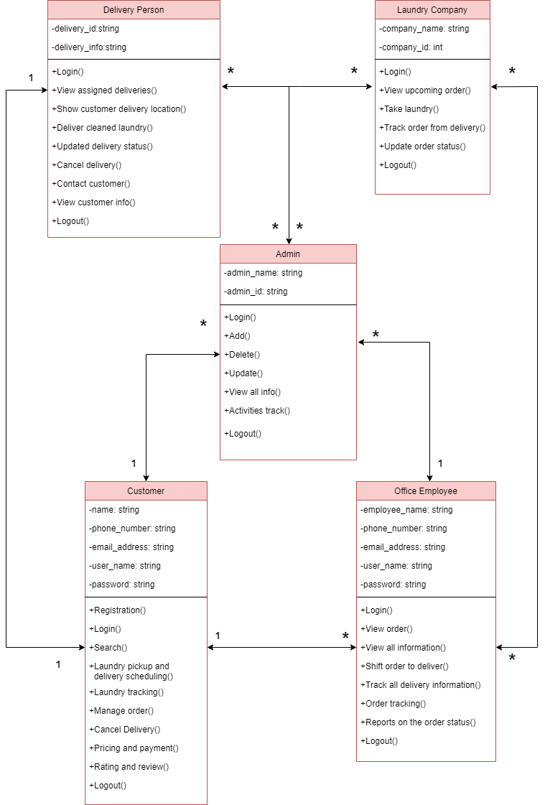

**Activity Diagram**

1. **USER STORY**

* **Admin**

| **User Story ID** | **User Story** | **Acceptance Criteria** |
| --- | --- | --- |
| US001 | As an Admin, I want to efficiently add new entities (Office Employee, Delivery Personnel, Laundry Company, and branches for different Laundry Companies) to the system. | 1. Access to a user-friendly interface for entity addition.  2. Validated input fields for each entity type.  3. Clear confirmation message for successful entity addition.  4. Ability to add multiple branches for a single Laundry Company.  5. Prevention of duplicate entries.  6. Immediate availability of added entities for system use. |
| US002 | As an Admin, I want to delete existing entities (Office Employee, Delivery Personnel, Laundry Company) from the system. | 1. Access to a user-friendly interface for entity deletion.  2. Prompt for user confirmation before deletion.  3. System ensures that deleting an entity does not cause data inconsistencies.  4. Prevention of accidental or unauthorized deletions. |
| US003 | As an Admin, I want to view all information related to Customers, Office Employees, Delivery Personnel, and Laundry Companies stored in the system. | 1. Access to a user-friendly interface for viewing information.  2. Ability to filter and sort displayed information based on various criteria.  3. Appropriate access controls to ensure authorized access only.  4. Accurate and up-to-date information displayed.  5. System scalability to handle concurrent requests for information. |
| US004 | As an Admin, I want to update information related to Customers, Office Employees, Delivery Personnel, and Laundry Companies stored in the system. | 1. Access to a user-friendly interface for updating information.  2. Ability to modify existing information and save changes.  3. System ensures updating an entity does not cause data inconsistencies.  4. Appropriate access controls to ensure authorized updates.  5. System scalability to handle concurrent requests for updates. |
| US005 | As an Admin, I want the system to track activities such as Office Employees' actions, real-time location of Delivery Personnel, and status of Customer orders. | 1. System ability to track Office Employee activities.  2. Real-time tracking of Delivery Personnel location.  3. Tracking the status of Customer orders from pickup to delivery.  4. System generates reports on Employee productivity and order fulfillment.  5. Clear and easy-to-use tracking interface with instructions.  6. Accurate and up-to-date tracking information.  7. System performance ensures fast and efficient tracking.  8. Privacy and security of Customer and Employee data in the tracking process.  9. System scalability to handle a large number of tracking requests in real-time. |

* **Office Employee**

| **User Story ID** | **User Story** | **Acceptance Criteria** |
| --- | --- | --- |
| US001 | As an Office Employee, I want to view orders placed by Customers and see the selected Laundry Company. | 1. Access to a user-friendly interface displaying a list of customer orders.  2. Display detailed order information, including Customer's name, contact information, delivery address, and selected Laundry Company.  3. Ability to filter and sort orders based on various criteria such as delivery date, order status, and Customer name.  4. System ensures accurate and up-to-date order information.  5. Usable interface with clear instructions for order viewing. |
| US002 | As an Office Employee, I want to shift orders by assigning a Delivery Person to take laundry from the Customer and give it to the Laundry Company. | 1. Access to a list of pending orders.  2. Ability to assign a pending order to a designated Delivery Person.  3. View and update the status of assigned orders as necessary.  4. Communication capability with the assigned Delivery Person for any issues or changes to the order.  5. Ability to generate reports on the order delivery status.  6. Usable and clear interface for order shifting with instructions.  7. System ensures accurate and up-to-date order and Delivery Person information.  8. Fast and efficient order processing with minimal loading times.  9. Privacy and security of Customer information and order details.  10. System scalability to handle a large volume of orders and Delivery Personnel. |
| US003 | As an Office Employee, I want to shift orders by assigning a Delivery Person to take back cleaned laundry from the Laundry Company and deliver it to the Customer. | 1. Receive cleaned laundry delivery requests from Laundry Companies.  2. View necessary information about the delivery, including Customer details, delivery location, and laundry items.  3. Assign the delivery to a specific Delivery Person to take back cleaned laundry from the Laundry Company and deliver it to the Customer.  4. Provide notifications to the assigned Delivery Person about the delivery details and location.  5. Track the Delivery Person's location and estimated time of arrival.  6. Update the delivery status and notify the Laundry Company and Customer about any changes.  7. Usable and clear interface for shifting orders with instructions.  8. System ensures accurate and up-to-date information for deliveries.  9. Fast and efficient processing of delivery requests and assignment of Delivery Persons.  10. Privacy and security of Customer and Delivery Person data and information.  11. System scalability to handle a large volume of delivery requests and real-time assignments. |
| US004 | As an Office Employee, I want to track the status of laundry orders. | 1. Access to a user-friendly interface for tracking orders.  2. Real-time updates on the progress of laundry orders, including pickup, delivery, and any delays.  3. View the location of Delivery Personnel and the estimated time of delivery.  4. Receive notifications of any issues or delays with orders.  5. Ability to update the status of orders as they are processed.  6. Reliable and accurate tracking information.  7. Fast and efficient tracking function with minimal loading times.  8. Privacy and security of order and Customer data.  9. System scalability to handle a large number of tracking requests and updates in real-time. |

* **Delivery Person**

| **User Story ID** | **User Story** | **Acceptance Criteria** |
| --- | --- | --- |
| US001 | As a Delivery Person, I want to view my assigned deliveries. | 1. Access to a user-friendly interface displaying a list of assigned deliveries.  2. Display detailed information about each delivery, including Customer name, delivery address, and items to be delivered.  3. Ability to filter and sort deliveries based on various criteria such as delivery date, order status, and Customer name.  4. System ensures accurate and up-to-date information on assigned deliveries.  5. Usable interface with clear instructions for viewing assigned deliveries. |
| US002 | As a Delivery Person, I want to update the status of deliveries assigned to me. | 1. Access to a list of assigned deliveries with the ability to update their status.  2. Options to change the delivery status, such as "en route," "delivered," or "delayed."  3. Ability to provide real-time updates on the delivery progress.  4. Communication capability with the Office Employee for any issues or changes to the delivery status.  5. Usable and clear interface for updating delivery status with instructions.  6. System ensures accurate and up-to-date delivery information.  7. Fast and efficient status updating with minimal loading times. |
| US003 | As a Delivery Person, I want to receive notifications for canceled deliveries. | 1. Automatic notifications for any canceled deliveries assigned to the Delivery Person.  2. Clear information on the reason for cancellation and any relevant details.  3. Options to view the updated status and details of canceled deliveries.  4. Ability to communicate with the Office Employee for clarification or reassignment.  5. Usable and clear interface for receiving and handling cancellation notifications with instructions. |
| US004 | As a Delivery Person, I want to view Customer information for my assigned deliveries. | 1. Access to Customer details associated with assigned deliveries.  2. View Customer name, contact information, and delivery address.  3. Usable interface with clear instructions for viewing Customer information.  4. System ensures accurate and up-to-date Customer details.  5. Privacy and security of Customer data and information. |
| US005 | As a Delivery Person, I want to contact the Customer for delivery coordination. | 1. Access to Customer contact information, including phone number or email.  2. Ability to initiate contact with the Customer for coordination purposes.  3. Usable and clear interface for contacting the Customer.  4. Respectful and professional communication with Customers.  5. Privacy and security of Customer contact information. |

* **Laundry Company**

| **User Story ID** | **User Story** | **Acceptance Criteria** |
| --- | --- | --- |
| US001 | As a Laundry Company, I want to view upcoming orders. | 1. Access to a user-friendly dashboard displaying a list of upcoming orders assigned to my company.  2. Display detailed information about each order, including Customer details, delivery address, and assigned Delivery Person.  3. Ability to filter and sort orders based on various criteria such as order date, status, and Customer name.  4. Real-time updates to ensure accurate and up-to-date information.  5. User interface is intuitive and provides clear instructions for viewing upcoming orders. |
| US002 | As a Laundry Company, I want to take laundry orders from the assigned Delivery Person. | 1. Receive notifications or alerts when a new laundry order is assigned by the Delivery Person.  2. Access to detailed information about the laundry order, including Customer details and specific instructions.  3. Option to accept or decline the order, with the ability to provide reasons for declination.  4. Clear communication channel with the Delivery Person for any queries or issues related to the order.  5. User-friendly interface with clear instructions for managing incoming laundry orders. |
| US003 | As a Laundry Company, I want to update the status of orders processed by my facility. | 1. Access to a list of orders with the ability to update their processing status.  2. Options to change the order status, such as "processing," "completed," or "delayed."  3. Ability to provide real-time updates on the order processing progress.  4. Communication capability with the Delivery Person for any issues or changes to the order status.  5. User interface is intuitive and provides clear instructions for updating the order status.  6. System ensures accurate and up-to-date order information.  7. Efficient status updating with minimal delays or system lags. |

* **Customer**

| **User Story ID** | **User Story** | **Acceptance Criteria** |
| --- | --- | --- |
| US001 | As a Customer, I want to register for an account on the platform. | 1. User-friendly registration form with fields for personal information and contact details.  2. Email verification process to ensure the validity of the registered account.  3. Clear and concise instructions for completing the registration process.  4. Ability to reset the password in case of forgotten credentials.  5. Confirmation message upon successful registration. |
| US002 | As a Customer, I want to search for laundry service providers. | 1. Search functionality with filters for location, services offered, and customer ratings.  2. Display of relevant laundry service providers with detailed profiles.  3. Access to information such as services offered, pricing, and customer reviews for each laundry service provider.  4. Intuitive navigation and a user-friendly interface for a seamless search experience. |
| US003 | As a Customer, I want to schedule laundry pickup and delivery. | 1. Calendar or date-picker feature for selecting pickup and delivery dates.  2. Options to specify preferred time slots for pickup and delivery.  3. Confirmation message with details of the scheduled pickup and delivery times.  4. Ability to reschedule or cancel the pickup and delivery with reasonable notice.  5. Real-time notifications or alerts for pickup and delivery updates. |
| US004 | As a Customer, I want to provide ratings and reviews for the laundry service. | 1. Access to a rating and review system after the completion of the service.  2. Options to rate various aspects such as service quality, timeliness, and communication.  3. Ability to leave written feedback or comments about the overall experience.  4. Confirmation message upon successful submission of the rating and review. |
| US005 | As a Customer, I want transparent pricing and multiple payment options. | 1. Clear and transparent display of pricing for different laundry services.  2. Information about any additional charges or fees.  3. Multiple payment options, including credit/debit cards, digital wallets, and other convenient methods.  4. Secure payment processing with confirmation messages for successful transactions. |
| US006 | As a Customer, I want an order management system. | 1. Access to a user-friendly dashboard displaying current and past orders.  2. Detailed order information, including service details, pickup and delivery status, and pricing.  3. Option to view and download invoices or receipts for completed orders.  4. Clear instructions for order modification or cancellation if needed. |
| US007 | As a Customer, I want to track the status of my laundry order. | 1. Real-time order tracking feature with updates on the pickup, processing, and delivery stages.  2. Notifications or alerts for any delays or changes in the order status.  3. Clear and intuitive interface for easy navigation and understanding of the order tracking system. |

1. **DATA DICTIONARY**

A data dictionary outlines the data elements and their characteristics within a system. This data dictionary provides a basic structure for the data entities and their attributes in the Online Laundry Management System. The foreign keys establish relationships between different tables. Here's a simplified data dictionary based on the features:

**USER TABLE:**

|  |  |  |  |  |
| --- | --- | --- | --- | --- |
| **Key** | **Name** | **Data Type** | **Length** | **Nullable** |
|  | Username | Varchar | 50 | No |
| Primary | UserID | Varchar | 10 | No |
|  | Password | Varchar | 30 | No |
|  | UserType (Customer, Delivery Person, Office Employee, Laundry Company) | Varchar | 20 |  |
|  | Address | Varchar | 50 | No |
|  | Phone | Varchar | 20 | No |
|  | Email | Varchar | 20 | No |
|  |  |  |  |  |

**LAUNDRY COMPANY TABLE:**

|  |  |  |  |  |
| --- | --- | --- | --- | --- |
| **Key** | **Name** | **Data Type** | **Length** | **Nullable** |
|  | CompanyName | Varchar | 50 | No |
| Primary | CompanyID | Varchar | 10 | No |
|  | Location | Varchar | 50 | No |
|  | ServicesOffered | Varchar | 50 | No |

**SCHEDULE TABLE:**

|  |  |  |  |  |
| --- | --- | --- | --- | --- |
| **Key** | **Name** | **Data Type** | **Length** | **Nullable** |
| Primary | ScheduleID | Varchar | 10 | No |
| Foreign | UserID | Varchar | 10 | No |
|  | PickupDateTime | Varchar | 20 | No |
|  | DeliveryDateTime | Varchar | 20 | No |

**NOTIFICATION TABLE:**

|  |  |  |  |  |
| --- | --- | --- | --- | --- |
| **Key** | **Name** | **Data Type** | **Length** | **Nullable** |
| Primary | NotificationID | Varchar | 10 | No |
| Foreign | UserID | Varchar | 10 | No |
|  | Message | Varchar | 100 | No |
|  | DateTime | Varchar | 20 | No |

**ORDER TABLE:**

|  |  |  |  |  |
| --- | --- | --- | --- | --- |
| **Key** | **Name** | **Data Type** | **Length** | **Nullable** |
| Primary | OrderID | Varchar | 10 | No |
| Foreign | UserID | Varchar | 10 | No |
|  | OrderDateTime | Varchar | 20 | No |
|  | TotalBill | Decimal |  | No |
|  | Status (Pending, In Progress, Completed) | Varchar | 20 | No |

**SHIFT TABLE:**

|  |  |  |  |  |
| --- | --- | --- | --- | --- |
| **Key** | **Name** | **Data Type** | **Length** | **Nullable** |
| Primary | ShiftID | Varchar | 10 | No |
| Foreign | OrderID | Varchar | 10 | No |
| Foreign | DeliveryPersonID | Varchar | 10 | No |
|  | ShiftDateTime | Varchar | 20 | No |

**CONTACT TABLE:**

|  |  |  |  |  |
| --- | --- | --- | --- | --- |
| **Key** | **Name** | **Data Type** | **Length** | **Nullable** |
| Primary | ContactID | Varchar | 10 | No |
| Foreign | UserID | Varchar | 10 | No |
|  | Message | Varchar | 100 | No |
|  | DateTime | Varchar | 20 | No |

**ORDER STATUS TABLE:**

|  |  |  |  |  |
| --- | --- | --- | --- | --- |
| **Key** | **Name** | **Data Type** | **Length** | **Nullable** |
| Primary | StatusID | Varchar | 10 | No |
| Foreign | OrderID | Varchar | 10 | No |
|  | Status(Pending, In Progress, Completed) | Varchar | 20 | No |
|  | DateTime | Varchar | 20 | No |

**PRICING TABLE:**

|  |  |  |  |  |
| --- | --- | --- | --- | --- |
| **Key** | **Name** | **Data Type** | **Length** | **Nullable** |
| Primary | PricingID | Varchar | 10 | No |
|  | ServiceType | Varchar | 50 | No |
|  | Price | Decimal |  | No |

**ORDER HISTORY TABLE:**

|  |  |  |  |  |
| --- | --- | --- | --- | --- |
| **Key** | **Name** | **Data Type** | **Length** | **Nullable** |
| Primary | HistoryID | Varchar | 10 | No |
| Foreign | UserID | Varchar | 10 | No |
| Foreign | OrderID | Varchar | 10 | No |
|  | Status(Pending, In Progress, Completed) | Varchar | 20 | No |
|  | DateTime | Varchar | 20 | No |

**CANCELLATION TABLE:**

|  |  |  |  |  |
| --- | --- | --- | --- | --- |
| **Key** | **Name** | **Data Type** | **Length** | **Nullable** |
| Primary | CancellationID | Varchar | 10 | No |
| Foreign | UserID | Varchar | 10 | No |
| Foreign | OrderID | Varchar | 10 | No |
|  | DateTime | Varchar | 20 | No |

**REVIEW TABLE:**

|  |  |  |  |  |
| --- | --- | --- | --- | --- |
| **Key** | **Name** | **Data Type** | **Length** | **Nullable** |
| Primary | ReviewID | Varchar | 10 | No |
| Foreign | UserID | Varchar | 10 | No |
| Foreign | OrderID | Varchar | 10 | No |
|  | Rating | Number |  | No |
|  | Comment | Varchar | 100 | No |
|  | DateTime | Varchar | 20 | No |

1. **PROJECT CONSTRAINTS**

|  |
| --- |
| **Project Constraints** |

|  |  |
| --- | --- |
| **Pickup and Delivery Time** | Customers must select a specific time slot for laundry pickup and delivery. This restriction helps in optimizing routes and managing logistics. |
| **Cancellation Policies** | Cancellation policies with specific timeframes (30-60 mins) for canceling orders without incurring charges. After 1-hour a Customer must bear the extra charges. |
| **Hide Identity** | Only the particular Delivery Person who is assigned to collect the laundry and to deliver it, can see the details of the Customer. |
| **Billing and Payment Processing** | Employees involved in billing and payment processing must follow strict guidelines to ensure accurate invoicing, payment processing, and financial record-keeping. |
| **Customer Feedback and Quality Assurance** | Employees involved in Customer service or order processing must follow guidelines for verifying and resolving Customer complaints and issues to maintain service quality. |

1. **REQUIREMENT ACCEPTANCE CRITERIA**

When we are defining requirements and acceptance criteria for our Online Laundry Management System, it's important to be thorough and specific to ensure the system meets the needs of our business or users. Here are some key requirements and acceptance criteria to consider:

|  |  |  |
| --- | --- | --- |
| **Scenario** | **Requirement** | **Acceptance** |
| **User Registration and Authentication** | Users should be able to register and log in securely. | Users can create accounts with a unique username and password, and they can log in with their credentials. |
| **Profile Management** | Users should be able to create and manage their profiles. | Users can update their personal information, contact details, and preferences. |
| **Laundry Booking** | Users should be able to schedule laundry pickups and deliveries. | Users can select the date and time for laundry pickup and delivery and receive confirmation notifications. |
| **Laundry Tracking** | Users should be able to track the status of their laundry. | Users can check the real-time status of their laundry orders, including when it is being processed and when it will be delivered. |
| **Customer Support** | Users should have access to customer support. | Users can contact customer support through various channels, such as chat, email, or phone, and receive timely assistance. |
| **Mobile-Friendly Interface** | The system should be accessible on mobile devices. | The interface is responsive and user-friendly on various mobile devices, allowing users to make bookings and monitor orders on the go. |
| **Security and Data Protection** | The system should prioritize data security and privacy. | The system can use encryption, authentication, and authorization measures to protect user data and comply with data protection regulations. |
| **Maintenance and Support** | The system should have regular maintenance and support. | The system provider can offer regular updates, bug fixes, and responsive customer support. |
| **Pricing and Payment** | Users should be able to view pricing and make payments. | Users can see a clear breakdown of laundry pricing, apply any discounts or promotions, and make secure payments through various payment methods. |
| **Order History** | Users should have access to their order history. | Users can view a detailed history of their past laundry orders, including order dates, items, and costs. |
| **Reporting and Analytics** | Users should have access to laundry performance reports. | Users can generate reports on order volumes, revenue, customer feedback, and other relevant metrics. |
| **Notifications** | Users should receive notifications regarding their laundry orders. | Users can receive notifications via email, SMS, or in-app alerts for order confirmations, pickup and delivery updates, and payment receipts. |
| **Laundry Service Provider Dashboard** | Service providers should have a dashboard to manage orders. | Service providers can view and manage incoming laundry orders, update order statuses, and communicate with customers. |

It's important to gather input from stakeholders, including users and laundry service providers, to ensure that these requirements and acceptance criteria are comprehensive and align with their needs and expectations.

1. **REQUIREMENTS CHANGE MANAGEMENT TOOLS & PROCEDURES:**

Here are some tools and techniques that can be employed for efficient requirements change management:

* **Requirements Management Software**:
  + Tools like IBM Engineering Requirements Management DOORS, Jama Connect, or Helix RM (formerly IBM Rational DOORS) are designed specifically for managing and tracking requirements.
* **Project Management Software**:
  + Platforms like Jira, Trello, or Asana can help manage requirements changes within the context of the overall project.
* **Version Control Systems**:
  + Git, Subversion, or Mercurial can be used to manage changes to requirements documents.
* **Spreadsheets**:
  + Tools like Microsoft Excel or Google Sheets can be used for simple change request tracking.
* **Collaboration and Communication Tools**:
  + Tools like Slack, Microsoft Teams, or email can be used to facilitate communication and collaboration among stakeholders.
* **Requirements Traceability Matrix (RTM)**:
  + A well-structured RTM helps in tracking requirements and their dependencies. Excel or a custom database tool can be used to maintain an RTM.
* **Wikis and Documentation Tools**:
  + Tools like Confluence or Wiki software can be used to maintain a repository of requirements documentation, making it easy to update and track changes.
* **Workflow Automation Tools**:
  + Tools like Zapier or Microsoft Power Automate can automate certain aspects of change management, such as notifying stakeholders, updating documents, and triggering follow-up actions when a change request is approved.

1. **REQUIREMENT PLAN REPORT:**

**Product:** **Online Laundry Management System**

|  |  |  |  |  |  |  |  |
| --- | --- | --- | --- | --- | --- | --- | --- |
| ID # | Name | Type | Status | Priority | Owner | Release | Complete Status |
| 1 | Login | Feature | Planned | High | Administrator | V-2.0 | In-Progress |
| 2 | Logout | Feature | Planned | High | Administrator | V-2.0 | In-Progress |
| 3 | Registration | Feature | Planned | High | Administrator | V-2.0 | In-Progress |
| 4 | Homepage | Feature | Planned | High | Administrator | V-2.0 | In-Progress |
| 5 | Add/Delete/Update/View (Customer, Delivery Person, Office Employee, Laundry Company | Feature | Planned | High | Administrator | V-2.0 | In-Progress |
| 6 | Laundry service provider search | Feature | Planned | High | Administrator | V-2.0 | In-Progress |
| 7 | Laundry pickup and delivery schedule | Feature | Planned | High | Administrator | V-2.0 | In-Progress |
| 8 | Notification | Feature | Planned | High | Administrator | V-2.0 | In-Progress |
| 9 | Order tracking | Feature | Planned | High | Administrator | V-2.0 | In-Progress |
| 10 | Shift order (Assign Delivery Person) | Feature | Planned | High | Administrator | V-2.0 | In-Progress |
| 11 | Update order status | Feature | Planned | High | Administrator | V-2.0 | In-Progress |
| 12 | Contact customers | Feature | Planned | High | Administrator | V-2.0 | In-Progress |
| 13 | Transparent pricing and payment option | Feature | Planned | High | Administrator | V-2.0 | In-Progress |
| 14 | Order history | Feature | Planned | High | Administrator | V-2.0 | In-Progress |
| 15 | Mobile App | Feature | Planned | High | Administrator | V-2.0 | In-Progress |
| 16 | Cancel delivery | Feature | Planned | Medium | Administrator | V-2.0 | In-Progress |
| 17 | Rating and review system | Feature | Planned | Medium | Administrator | V-2.0 | In-Progress |
| 18 | AI-powered laundry sorting | Feature | Planned | Low | Administrator | V-2.0 | Not Completed |
| 19 | Integration with other home appliance | Feature | Planned | Low | Administrator | V-2.0 | Not Completed |
| 20 | Cryptocurrency payment | Feature | Planned | Low | Administrator | V-2.0 | Not Completed |

1. **PROTOTYPE DESIGN**

First the users will see this Login page.

Then, if the user already has an account, he or she needs to login with their username and password. If not, then by clicking the Register button the users can create their account. Also, if any user forgot the password, he can recover it through “Forgot password?” button.

Verification page.

Basic information page.

After submitting, this box will be shown.

This is the Home page view for the Customers.

Laundry Service Provider Search page.

|  |  |
| --- | --- |
|  |  |

Notification page.

Track Order Page.

Order History Page.

Payment Option Page.

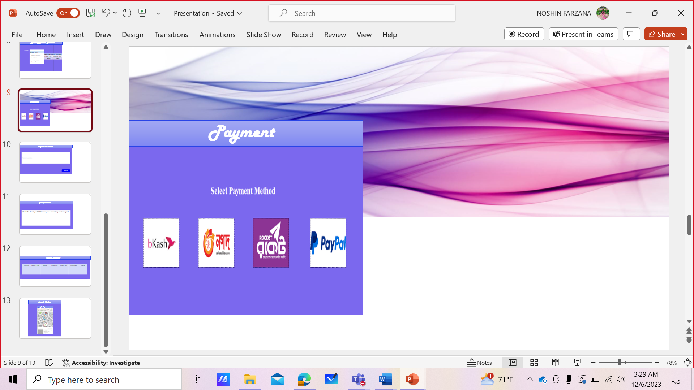

Rating & Review page.

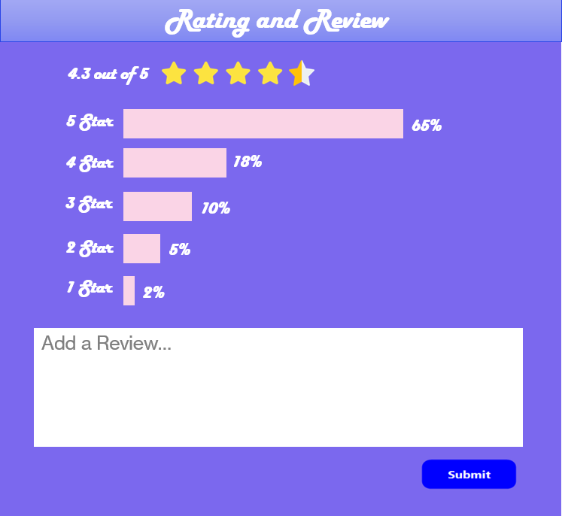

If Customers face any kind of problem, they can report.

1. **SELECTION PROCESS MODEL:**

After studying several Software Engineering process models, we have decided to use Agile (SCRUM). We believe that this model is appropriate for our project **Online Laundry Management System**.

Among all other process model to develop our proposed software we chose SCRUM process model because:

SCRUM has 3 phases-

1. Pre-game

Pre-game phase includes 2 sub-phases-

1. Planning
2. Architecture
3. Development/ Game phase
4. Post-game

As our proposed system is **Online Laundry Management System**, we preferred to have a product backlog list where all the currently known requirements are listed as well as the requirements are prioritized, and effort needed for the implementation is estimated. Our product backlog list will be constantly updated with new and more detailed items, as well as with more accurate estimations and new priority orders. The architecture phase work is based on our current items in the product backlog list. In case we need any enhancement to our existing system, we can do this in this phase.

Next, the development/game phase is divided into parts. Each division is called sprint. In each sprint traditional phases of software development like requirements, analysis, design, evolution, and delivery are used.

Lastly, the post-game phase entered when an agreement has been made such as the requirements are completed. This phase does the work of integration, system testing and documentation. After this our project is going to be ready for release.

During the processing SCRUM has several meetings which will help our team to complete project deliverables quickly and efficiently. As our **Online Laundry Management System** is quite a long project and we need to change the requirements at any time, SRUM is best. SCRUM divided it into easily manageable sprints. Here developments are coded and tested during sprint review. For, fast moving development project SCRUM works well. Moreover, SCRUM ensures effective use of time and money.

**Project Role Identification and Responsibilities:**

* **SCRUM Master:** SCRUM Master interacts with the project team as well as with the customer and the management during the project. He is responsible for ensuring that the project is carried out according to the practices, values, and rules of SCRUM and that it progresses as planned.
* **Product Owner:** The Product Owner is officially responsible for the project, managing, controlling, and making visible the Product Backlog list.
* **SCRUM Team:** SCRUM Team is the project team that has the authority to decide on the necessary actions and to organize itself to achieve the goals of each Sprint. The SCRUM team is involved in effort estimation, creating the Sprint Backlog, reviewing the product Backlog list, and suggesting impediments that need to be removed from the project.
* **Customer:** Customer participates in the tasks related to product Backlog items for the system being developed or enhanced.
* **Management:** Management oversees final decision making, along with the agreements, standards, and conventions to be followed in the project.

SCRUM, Waterfall are project management methodologies used in software development. Here are the main differences between these methodologies:

* **SCRUM:** It is a flexible and iterative approach to project management. In this methodology, the development team works in short sprints, typically one to four weeks long, to deliver a working product iteratively. The focus is on delivering value to the customer and adapting to changing requirements as the project progresses. The team is self-organizing, and there is a high degree of collaboration between team members, stakeholders, and the customer.
* **Waterfall (Plan-Driven):** Waterfall is a linear, sequential approach to project management. In this model, the project is divided into distinct phases, such as planning, design, development, testing, and deployment. Each phase must be completed before moving on to the next one. The focus is on completing each phase before moving on to the next, and the project's requirements and objectives are defined at the beginning of the project. We cannot go back to the previous phase to change the requirements. This methodology is less flexible than SCRUM and can result in longer development times and less customer involvement. So, we cannot use this model for our project as in our project requirements are continuously changing and customer interaction is needed.

In summary, SCRUM is a flexible, iterative approach to project management, Waterfall is a linear, sequential approach. Comparing with all these process models, we have selected SCRUM model for our project.

## DEVELOPMENT PLAN

## Development Plan:

Projects contain deadlines, spending limits, and specifications that must be met. The project plan is created using Agile project planning. Agile project management is made to be adaptable enough to handle tasks that could potentially move, change, or evolve. An agile team can clearly see the objectives of their project thanks to Agile planning. We used the iterative and incremental Scrum Agile development methodology to create this Online Laundry Management System software. Scrum is an agile framework created with the user in mind at all stages of the project's development. It is extremely versatile, easy to use, quick, flexible, and efficient.

Scrum's primary goal is to meet the users' needs by creating an environment of open communication, shared responsibility, and continuous improvement. The development process begins with a fundamental understanding of what needs to be constructed, followed by developing a list of characteristics sorted by priority (product backlog) that the product's owner desires.

It’s typically divided in between six to eight steps here we will about the seven steps:

### Planning, Requirements and Feasibility analysis, Design, Development, Testing, Deployment and Maintenance

* **Planning:** In the Planning phase,
* We will discuss about the plan or the steps to achieve our next goal.
* Our developers will evaluate the terms of the project.
* **Requirements and Feasibility analysis:** In order to ensure the success of the project, it is important to conduct a thorough requirements and feasibility analysis. This involves collecting and analyzing information about the system's users, as they will be the ones using the system. To gather these requirements, we will be using questionnaires to gain a better understanding of how our system will function. This process will take approximately one week to complete. Additionally, we will need to determine which features are necessary and which can be omitted, and brainstorm potential solutions to any challenges that may arise. By conducting a feasibility analysis, we can determine whether the application we want to build is viable and cost-effective, and make any necessary changes before design and development begin. This will help us to create a more successful and efficient product in the long run. The brainstorming and analysis process will take at least one to two weeks to complete, ensuring that we have a comprehensive understanding of the project's requirements before moving forward.
  + **Design:** The Design phase models the way a software application will work. Some aspects of the design include:

Architecture – Specifies programming language, industry practices, overall design, and use of any templates or boilerplate.

User Interface – Defines the ways customers interact with the software, and how the software responds to input.

Platforms – Defines the platforms on which the software will run, such as Apple, Android, Windows version, Linux, or even gaming consoles.

Programming – Not just the programming language, but including methods of solving problems and performing tasks in the application.

Communications – Defines the methods that the application can communicate with other assets, such as a central server or other instances of the application.

* + **Development**: The programming phase of software development is where the actual code is written. Depending on the size and complexity of the project, this may be done by a single developer or by multiple teams. During this phase, developers must carefully track any changes to the code and ensure that it remains compatible with other parts of the project. This is especially important for large projects where multiple teams are working on different aspects of the software. By closely monitoring progress and maintaining open communication, developers can ensure that the project stays on track and that target goals are being met. For our particular project, we estimate that the coding phase will take approximately five weeks to complete, allowing us to stay on schedule and deliver the final product on time.
  + **Testing:** Software testing is a critical phase of the software development process that allows us to ensure that the system is functioning correctly and meeting all of the necessary requirements. To accomplish this, we will be running a series of tests that will include both white box and black box testing. Additionally, we will be testing for regression and acceptance to ensure that the system is operating properly and meeting the needs of our users. This testing process is essential to guaranteeing the success of our project and demonstrating the quality of our system. We plan to begin testing after the coding portion of the project has been completed in approximately two weeks. During this time, we will be performing unit testing and integration testing, with the developers responsible for conducting the unit testing. It is crucial to ensure that the system functions correctly during this phase, and as a result, a significant amount of testing is necessary. Any errors that are identified during testing will need to be corrected to ensure that the system meets all of the necessary requirements and functions correctly for our users.
* **Implementation and Deployment:** A crucial step in the software development process, the deployment phase signifies the change from development to actual end-user use. We will launch our application during this phase after performing pre-launch testing to make sure it is prepared for use. This stage is crucial since it specifies how our program will operate before going live, ensuring that it satisfies all prerequisites and works as intended in a practical setting. We will keep a careful eye on the deployment procedure to make sure everything is going as planned and that any problems are immediately found and fixed. Our goal is to provide a seamless experience for our users and ensure that the application is fully functional and ready for use before it goes live. By following a rigorous deployment process, we can guarantee that our application is of the highest quality and meets the needs of our users.
* **Operations and Maintenance:** The maintenance phase is the last stage of the software development cycle. Our application is made available to our clients at this phase and is rolled out for live operation. Even while we work hard to catch any defects and problems during testing, there can still be some that aren't visible until after the application has been used. We will designate resources to sustain the development cycle so that our application stays functional and continues to satisfy the needs of our users. As an alternative, to guarantee that any difficulties are resolved promptly, we can sign a software maintenance agreement with our development team or a third party. This phase is crucial because it ensures that our application continues to function correctly and remains relevant and useful to our users. By maintaining the development cycle, we can ensure that our application remains up to date and that any issues are resolved quickly and efficiently, providing a seamless experience for our users.

1. **PROJECT SCHEDULE:**

**Planning Phase:** 1-2 Weeks

**Requirements and Feasibility Analysis Phase:** 3-4 Weeks

**Design Phase:** 5-6 Weeks

**Development Phase:** 7-20 Weeks

**Testing Phase:** 21-24 Weeks

**Deployment Phase:** 25-26 Weeks

**Marketing Phase:** 27-28 Weeks

**Maintenance Phase:** 29 -53 Weeks

|  |  |  |  |
| --- | --- | --- | --- |
| **Phase** | **Tasks** | **Timeline (Week)** | **Day** |
| **1. Planning Phase** | Define project scope and objectives | Week 1 | Day 1-2 |
| Identify stakeholders and their requirements | Week 1 | Day 3-4 |
| Determine budget and resources | Week 1 | Day 5-6 |
| Create project plan | Week 2 | Day 1-3 |
| Finalize project plan | Week 2 | Day 4-5 |
| Review and approve project plan | Week 2 | Day 6 |

|  |  |  |  |
| --- | --- | --- | --- |
|  | Conduct a Feasibility study | Week 3 | Day 1-2 |
| **2. Analysis Phase** | Conduct a cost-benefit analysis | Week 3 | Day 3-4 |
| Identify potential risks and mitigation strategies | Week 3 | Day 5-6 |
| Determine technical requirements | Week 4 | Day 1-3 |
| Define functional and non-functional requirements | Week 4 | Day 4-6 |
| **3. Design Phase** | Create a wireframe | Week 5 | Day 1-2 |
| Develop a detailed technical design | Week 5 | Day 3-4 |
| Create a detailed project plan | Week 5 | Day 5-6 |
| Create a database design and schema | Week 6 | Day 1-3 |
| Finalize design phase | Week 6 | Day 4-5 |
| Review and approve design phase | Week 6 | Day 6 |

|  |  |  |  |
| --- | --- | --- | --- |
|  | Build the front-end and back-end of the application | Weeks 7-10 | Day 1-6  (4 Weeks) |
|  | Integrate any necessary third-party services or APIs | Weeks 11-14 | Day 1-6  (4 Weeks) |
| **4. Development Phase** | Perform unit testing to ensure each component functions correctly | Weeks 15-18 | Day 1-5 |
| Conduct code reviews and make necessary changes | Weeks 15-18 | Day 6 |
| Finalize development phase | Weeks 19-20 | Day 1-4 |
| Review and approve development phase | Weeks 19-20 | Day 5-6 |
| **5. Testing Phase** | Perform system testing to ensure the application works as expected | Week 21 | Day 1-4 |
| Conduct user acceptance testing to ensure the application meets the stakeholders' requirements | Week 22 | Day 1-5 |
| Identify and resolve any issues | Week 22-23 | Day 6-2 |
| Finalize testing phase | Weeks 23-24 | Day 3 -1 (week 23) -  (week 24) |
| Review and approve testing phase | Weeks 24 | Day 2-6 |
| **6. Deployment Phase** | Deploy the application to the production environment | Week 25 | Day 1-4 |
| Monitor the application | Week 25 | Day 5-6 |
| and resolve any issues |  |  |
| Finalize deployment phase | Week 26 | Day 1-4 |
| Review and approve deployment phase | Week 26 | Day 5-6 |
| **7. Marketing Phase** | 1. Market Research 2. Branding 3. Advertising 4. Content Marketing 5. Public Relations | Week 27-28 | Day1-6  (2 weeks) |
| **8. Maintenance**  **Phase** | Provide ongoing support and maintenance for the application |  |  |
| Address any bugs or issues that arise |  |  |

We are pleased to provide our customers with free maintenance for the first 24 weeks (about 5 and a half months) after the initial deployment of the software application. During this time, our team will be available to address any bugs or issues that arise, as well as perform necessary updates and improvements to ensure optimal performance.

After the initial 24 weeks (about 5 and a half months), we will begin to charge for maintenance services. Our team will work closely with software buyers to develop a maintenance plan that best fits the needs and budget. We are committed to providing exceptional customer support and ensuring the ongoing success of the software application.

### Figure: The total Calendar for the Project of Online Laundry Management System

**Figure: The total Gantt for the Project of Online Laundry Management System**

**Project Timeline Table**

|  |  |  |  |
| --- | --- | --- | --- |
| **Project Timeline** | | **Table** |  |
| **Date** | **Task name** | **Assigned to** | **Status** |
| 15/5/2022 | Project start |  |  |
| 20/5/2022 | Define project scope and objective | Noshin Farzana | In-Progress |
| 24/6/2022 | Identify Stakeholders | Avijit Saha Anto | In-Progress |
| 9/9/2022 | Determine budget and resource | Noshin Farzana | Open |
| 14/10/2022 | Create project plan | Noshin Farzana | Open |
| 5/1/2023 | Finalize project plan | Avijit Saha Anto | Open |
| 27/2/2023 | Review and approve project plan | Sadikul Mobasshir | Open |
| 4/4/2023 | Conduct a feasibility study | Noshin Farzana | Open |
| 30/6/2023 | Conduct a cost-benefit analysis | Avijit Saha Anto | Open |
| 7/8/2023 | Identify potential risk | Noshin Farzana | Open |
| 11/9/2023 | Determine technical requirements | Sadikul Mobasshir | Open |
| 2/10/2023 | Determine functional and non- functional requirements | Avijit Saha Anto | Open |
| 6/11/2023 | Create a wireframe | Noshin Farzana | Open |
| 8/12/2023 | Develop a detailed technical documentation | Sadikul Mobasshir | Open |
| 23/12/2023 | Quality assurance | Avijit Saha Anto | Open |
| 12/1/2024 | Create a detailed project plan | Noshin Farzana | Open |
| 5/2/2024 | Create database design | Avijit Saha Anto | Open |

1. **MARKETING PLAN:**

After building the software or system, we have to make a proper marketing plan to familiarize the software with the people. Marketing plans play a great role to boost in sales. There are many marketing approaches available that we can follow. Traditional and Digital Marketing is one of the popular branches of Marketing. Nowadays Digital Marketing is getting more popular than the traditional approaches of marketing. Marketing plans can be Short-term, Long-term and Continuous plan. The plan is described below-

* **Short-term marketing plan:**

Plans for short-term marketing are intended to provide outcomes quickly and in the here and now. The main objective is to fast boost sales and revenue. These strategies frequently involve quick-acting digital marketing techniques including email marketing, pay-per-click (PPC) advertising, social media campaigns, and others. These strategies are often carried out over a few weeks or months.

Among the short-term marketing strategies that will be used for our software:

* + Direct mail (mailing direct to potential customers).
  + Newspaper advertisements (printing advertisements in newspapers, magazines, brochures, flyers, etc.).
  + The billboards (displaying signs along roadsides).
  + Outdoor marketing (placing ads in public places like bus shelters, subway stations, etc).
  + Phone marketing (calling people at home using prerecorded messages).
  + Internet marketing (advertising online, including websites).
  + Trade Expos Special Savings Price reductions for a short period of time.
* **Long-term marketing plan:**

On the other hand, Long-term marketing plans emphasize accomplishing long-term objectives over a considerable amount of time. These strategies are meant to solidify the brand's reputation, create a devoted following, and expand market share. Long-term marketing strategies frequently include tasks like public relations, influencer marketing, search engine optimization (SEO), and content marketing. These strategies are carried out over several months or perhaps years.

The long-term marketing activities for our software includes:

Search Engine Optimization (SEO): The implementation of search engine optimization (SEO), a long-term marketing strategy, takes time and effort. It entails knowing who your target market is and configuring your website to show up for relevant keywords and phrases in search engine results pages. Working with a professional is vital if you want to regularly update and optimize your website for search engines.

* + Content marketing: In order to draw in and keep the attention of a clearly defined target, content marketing is a strategic technique that comprises producing and disseminating useful and pertinent material. It's a methodical strategy that can develop leads and build brand authority over time. Short-term, long-term, and continual goals can all be accomplished through the usage of content marketing.
  + Social media: A potent marketing tool, social media may be used to accomplish both short-term and long-term objectives. It can be applied to managing online reputation, participating in online communities, and raising brand recognition among prospective buyers. Frequent social media updates can assist keep our brand in the public eye and offer your audience useful information. Social media is an ongoing strategy that can aid in gaining a devoted following over time.

Online communities on social media platforms like Facebook, Twitter, Instagram, LinkedIn, and others can help us draw in top talent and build brand recognition among potential clients. By consistently appearing in users' social news feeds, we may retain their attention. Curiosity is piqued by interesting posts. People remember helpful advice and the source of it.

* **Continuous marketing plan:**

Plans for continuous marketing entail consistent, ongoing marketing activities. These strategies are crucial for preserving a dominant market position and guaranteeing that the software or system continues to be pertinent to the intended audience. Examples of ongoing marketing initiatives include social media maintenance, content production, and email marketing. These strategies are carried out indefinitely, frequently with periodic evaluations and adjustments to make sure the marketing initiatives continue to be successful.

Examples of conventional media include print, television, and radio. Whether it's billboards on the side of the road or online advertisements for our laundry express, advertising is thought of as an indication of the good or service.

1. **COST & PROFIT ANALYSIS:**

**Project Estimation**

An algorithmic software cost estimating methodology is the Constructive Cost Model (COCOMO). We will be using an organic software project type. It is a software project that must be worked on in a hardware-dependent environment.

**Constructive Cost Model**

We are assuming the SLOC (Source Lines of Code) that we require here after analyzing all the components.

SLOC = 35,000

Now we need to figure out the effort, development time, and required number of people.

Suppose that our software project type is organic, the values of the Coefficient<Effort Factor> =2.5 P = project complexity = 1.25

SLOC= 35,000

T= SLOC-dependent coefficient = 0.40

Now,

Effort = PM = Coefficient*(SLOC/1000) P

PM = 2.5*(35000/1000)1.25

= 212.83

Development Time= DM= 2.5*(PM)T

= 2.5*(212.83)0.40

= 21.34

= 22 [In months]

Required Number of People = ST

= PM/DM

= 212.83/21.34

= 9.97

= 10

Total Development time: 22 months

Total working hours needed:

(22*22) *8= 3,872hours; (1 month = 22 working day & per day working time 8 hours)

Requirement Analysis & Documentation times needed: 22*22=484hours

Times needed for Ui/UX designing:

(2*22) *22=968 hours

Times needed for developing system:

(7*22) *22= 3,388 hours

Times needed for Testing & Debugging:

(3*22) *22= 1,452 hours

Revision time:

(2*22) *22= 968 hours.

To develop the software:

* Developer team of 5 engineers.
* Software Quality assurance team of 2 engineers.
* One Business Analyst
* Two Ui/UX Designer
* Total budget: **5,500,000 BDT**

**Cost Analysis**

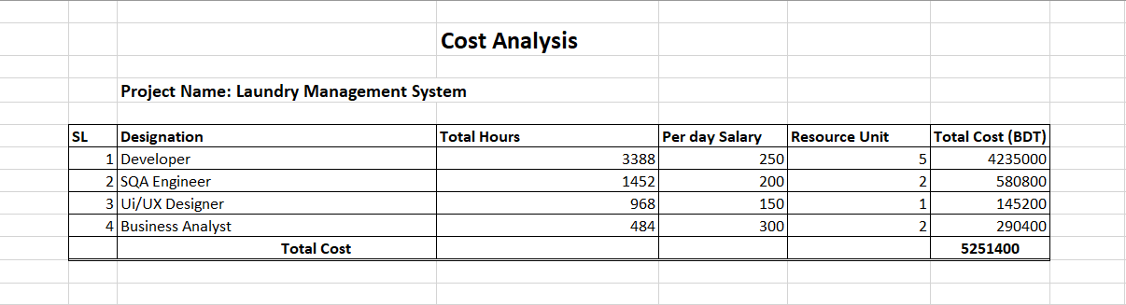

**Now, All together**

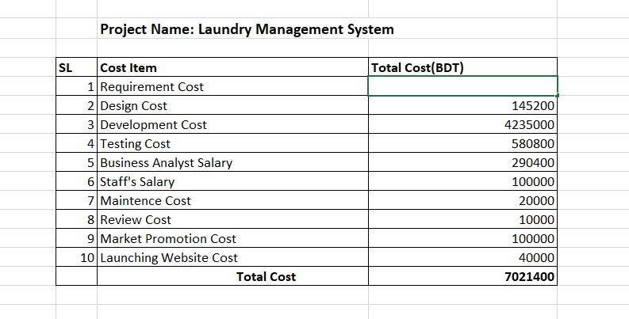

## Profit:

We set our monthly maintenance rate at 250 BDT. We are assuming at least 2550 people will use our app.

So, 2550 X 250 = 637,500 BDT

So, in 22 months it will be 637500 *22 = 14025000 BDT Our Total Development cost = 7021400 BDT

So, earnings on this website = 14025000 BDT

So, we are getting (14025000-7021400) = 7003600 BDT profit. After one-year subscription fee will be reduced.

1. **OPERATING ENVIRONMENT**

The operating environment of an Online Laundry Management System encompasses the various factors and conditions that affect its performance, functionality, and interactions. Here are key aspects of the operating environment for such a system:

* **Technology Infrastructure:**
  + **Server Infrastructure:** The system relies on robust servers to host the application, databases, and handle data processing.
  + **Database Management System (DBMS):** The choice of DBMS affects data storage, retrieval, and management. Common systems include MySQL, PostgreSQL, or NoSQL databases.
  + **Programming Languages and Frameworks:** The system may be built using languages like Python, Java, or PHP, and frameworks such as Django, Flask, Spring, or Laravel.
* **Network Infrastructure:**
  + **Internet Connectivity:** Users access the system via the internet, making a stable and secure connection crucial.
  + **Bandwidth:** Sufficient bandwidth is needed for smooth data transfer, especially when dealing with multimedia content.
* **Client Devices:**
  + **Web Browsers:** Compatibility with major web browsers like Chrome, Firefox, Safari, and Edge is essential.
  + **Mobile Devices:** As many users may access the system via mobile devices, responsiveness and mobile optimization are critical.
* **Security Measures:**
  + **Encryption:** Implementation of SSL/TLS protocols to ensure secure data transmission.
  + **Authentication and Authorization:** Robust user authentication and authorization mechanisms to protect user accounts and sensitive information.
* **Regulatory Compliance:**
  + **Data Protection Laws:** Compliance with data protection regulations such as GDPR, HIPAA, or other regional data protection laws.
  + **Payment Card Industry Data Security Standard (PCI DSS):** If handling payment information, compliance with PCI DSS is crucial.
* **External Integrations:**
  + **Payment Gateways:** Integration with secure payment gateways for online transactions.
  + **APIs:** Integration with third-party services, such as delivery services, for seamless operations.
* **Geographical Considerations:**
  + **Localization:** The system should support multiple languages and regional preferences.
  + **Geographical Delivery Zones:** Consideration of service availability based on geographical locations.
* **Scalability and Performance:**
  + **Scalability:** The system should be scalable to accommodate an increasing number of users and data.
  + **Performance Monitoring:** Implementation of tools to monitor system performance and address bottlenecks.
* **User Support and Training:**
  + **Helpdesk and Support:** Provision of customer support for query resolution.
  + **User Training:** Training materials or sessions for users and administrators.
* **Environmental Factors:**
  + **Power and Backup Systems:** Ensuring a stable power supply and backup systems in case of outages.
  + **Data Backup and Recovery:** Regular data backups and recovery mechanisms to prevent data loss.
* **Business Continuity and Disaster Recovery:**
  + **Contingency Planning:** Plans for business continuity in case of unforeseen events or disasters.
  + **Data Recovery Procedures:** Procedures for recovering data in case of data loss or system failure.

Considering these factors helps ensure that the Online Laundry Management System operates efficiently, securely, and meets the needs of users and stakeholders.

1. **TEST CASE DESIGN**

|  |  |  |  |  |  |
| --- | --- | --- | --- | --- | --- |
| Project Name: Online Laundry Management System | | | | Test Designed by: Noshin | |
| Test Case ID: FR_1_1  Test priority (Low, Medium, High): High  Module Name: Login | | | | Test Designed date: 06-12-2023 | |
| Test Title: Verify login with valid username and password | | | |  | |
| Description: Test app login page  Precondition (If any): User must have valid username and password | | | |  | |
| Test Steps | Test Data | Expected Results | Actual Results |  | Status  (Pass/Fail) |
| 1. Go to app 2. Enter username 3. Enter password 4. Click login | Username: Noshin Farzana  Password: 667 | User should login into the application | As expected |  | Pass |
| Post Condition: User is validated with database and successfully login to account. The account session details are logged in the database. | | | | | |

|  |  |  |  |  |  |
| --- | --- | --- | --- | --- | --- |
| Project Name: Online Laundry Management System | | | | Test Designed by: Noshin | |
| Test Case ID: FR_1_2  Test priority (Low, Medium, High): High  Module Name: Login | | | | Test Designed date: 06-12-2023 | |
| Test Title: Verify login with wrong username and password | | | |  | |
| Description: Test app login page  Precondition (If any): User doesn’t need valid username and password | | | |  | |
| Test Steps | Test Data | Expected Results | Actual Results |  | Status  (Pass/Fail) |
| 1. Go to app 2. Enter username 3. Enter password 4. Click login | Username: Nfe  Password: 123 | User should not login into the application | As expected |  | Pass |
| Post Condition: User is not validated with database and could not login to account. | | | | | |

|  |  |  |  |  |  |
| --- | --- | --- | --- | --- | --- |
| Project Name: Online Laundry Management System | | | | Test Designed by: Noshin | |
| Test Case ID: FR_2  Test priority (Low, Medium, High): High  Module Name: Logout | | | | Test Designed date: 06-12-2023 | |
| Test Title: Logout from the system | | | |  | |
| Description: Test app logout  Precondition (If any): User must login to the system | | | |  | |
| Test Steps | Test Data | Expected Results | Actual Results |  | Status  (Pass/Fail) |
| 1. Click logout button |  | User should be able to logout anytime from homepage | As expected |  | Pass |
| Post Condition: User is validated with database and successfully logged out from system. | | | | | |

|  |  |  |  |  |  |
| --- | --- | --- | --- | --- | --- |
| Project Name: Online Laundry Management System | | | | Test Designed by: Noshin | |
| Test Case ID: FR_3  Test priority (Low, Medium, High): High  Module Name: Forgot Password | | | | Test Designed date: 06-12-2023 | |
| Test Title: Set new password | | | |  | |
| Description: Test app forgot password  Precondition (If any): User must have valid username, phone number and email | | | |  | |
| Test Steps | Test Data | Expected Results | Actual Results |  | Status  (Pass/Fail) |
| 1. Go to app 2. Click forgot password 3. Enter username 4. Enter phone number 5. Enter email 6. Verify details 7. Set new password | New Password: abcd | User will be able to set new password | As expected |  | Pass |
| Post Condition: User successfully set new password. | | | | | |

|  |  |  |  |  |  |
| --- | --- | --- | --- | --- | --- |
| Project Name: Online Laundry Management System | | | | Test Designed by: Noshin | |
| Test Case ID: FR_4  Test priority (Low, Medium, High): High  Module Name: Registration | | | | Test Designed date: 06-12-2023 | |
| Test Title: Register to the system | | | |  | |
| Description: Test app registration page  Precondition (If any): User must have valid phone number and email | | | |  | |
| Test Steps | Test Data | Expected Results | Actual Results |  | Status  (Pass/Fail) |
| 1. Go to app 2. Click register 3. Enter phone number 4. Enter email 5. Choose country code 6. Enter 6 digit code to verify 7. Fill the basic information form 8. Click submit | Phone: 01752930004  Email: [noshinfarzana681@gmail.com](mailto:noshinfarzana681@gmail.com)  Country code: +880  Verify Code: 146808  Name: Noshin Farzana  Gender: Female  Date of Birth: 30/11/2001  Occupation: Student  Set password: 667  Address: House-20, Road-10, Shekhertek, Mohammadpur, Dhaka | User should be able to do registration by enter phone number, email, and country code.  User should be able to submit verification code and verify.  User should be able to fill the basic information form. | As expected |  | Pass |
| Post Condition: User is successfully registered to the system. | | | | | |

|  |  |  |  |  |  |
| --- | --- | --- | --- | --- | --- |
| Project Name: Online Laundry Management System | | | | Test Designed by: Noshin | |
| Test Case ID: FR_5  Test priority (Low, Medium, High): High  Module Name: Laundry Service Provider Search | | | | Test Designed date: 06-12-2023 | |
| Test Title: Search Laundry Service Provider in app | | | |  | |
| Description: Test app search page  Precondition (If any): User must login to the system | | | |  | |
| Test Steps | Test Data | Expected Results | Actual Results |  | Status  (Pass/Fail) |
| 1. Go to app 2. Login 3. Click Laundry Service Provider 4. Search Laundry Service Provider 5. Select Pickup & Delivery Schedule 6. Place Order | See the available Laundry Service Provider  Pickup Time: 8AM  Delivery Time: 6 PM | User will be able to search | As expected |  | Pass |
| Post Condition: User successfully searched all the options and placed order. | | | | | |

|  |  |  |  |  |  |
| --- | --- | --- | --- | --- | --- |
| Project Name: Online Laundry Management System | | | | Test Designed by: Noshin | |
| Test Case ID: FR_6  Test priority (Low, Medium, High): High  Module Name: Notification | | | | Test Designed date: 06-12-2023 | |
| Test Title: Get notification from app | | | |  | |
| Description: Test app notification page  Precondition (If any): User must login to the system | | | |  | |
| Test Steps | Test Data | Expected Results | Actual Results |  | Status  (Pass/Fail) |
| 1. Go to app 2. Login 3. Place Order 4. Get notification of assigned Delivery Person details 5. Get notification of the order status to change (from "In-Progress" to "Completed") 6. Get notification of offers | Place Order  Notification: Thanks for choosing us!!!  We’ll inform you when a Delivery Person is assigned. | User will be able to see notification | As expected |  | Pass |
| Post Condition: User successfully got notifications. | | | | | |

|  |  |  |  |  |  |
| --- | --- | --- | --- | --- | --- |
| Project Name: Online Laundry Management System | | | | Test Designed by: Noshin | |
| Test Case ID: FR_7  Test priority (Low, Medium, High): High  Module Name: Track Order | | | | Test Designed date: 06-12-2023 | |
| Test Title: Track order in app | | | |  | |
| Description: Test app Tracking page  Precondition (If any): User must login to the system | | | |  | |
| Test Steps | Test Data | Expected Results | Actual Results |  | Status  (Pass/Fail) |
| 1. Go to app 2. Login 3. Place Order 4. Track the order by monitoring location | Place Order    Track Order Location: Dhanmondi | User will be able to track | As expected |  | Pass |
| Post Condition: User successfully tracked the order. | | | | | |

|  |  |  |  |  |  |
| --- | --- | --- | --- | --- | --- |
| Project Name: Online Laundry Management System | | | | Test Designed by: Noshin | |
| Test Case ID: FR_8  Test priority (Low, Medium, High): High  Module Name: Order History | | | | Test Designed date: 06-12-2023 | |
| Test Title: See order history in app | | | |  | |
| Description: Test app order history page  Precondition (If any): User must login to the system | | | |  | |
| Test Steps | Test Data | Expected Results | Actual Results |  | Status  (Pass/Fail) |
| 1. Go to app 2. Login 3. Place multiple orders with different dates 4. Navigate to the Order History section | Place order    View a list of all previously placed orders, including order details (date, status, service name) | User will be able to see order history | As expected |  | Pass |
| Post Condition: User has successfully seen the order history. | | | | | |

|  |  |  |  |  |  |
| --- | --- | --- | --- | --- | --- |
| Project Name: Online Laundry Management System | | | | Test Designed by: Noshin | |
| Test Case ID: FR_9  Test priority (Low, Medium, High): High  Module Name: Payment | | | | Test Designed date: 06-12-2023 | |
| Test Title: Online Payment | | | |  | |
| Description: Test app pay online  Precondition (If any): User must login to system | | | |  | |
| Test Steps | Test Data | Expected Results | Actual Results |  | Status  (Pass/Fail) |
| 1. Go to app 2. Login 3. Place Order 4. Click Payment 5. Choose payment method 6. Send money | Payment method: Bkash  Total Bill: 300.00  Send money | User will be able to pay online | As expected |  | Pass |
| Post Condition: User successfully paid via online payment method. | | | | | |

|  |  |  |  |  |  |
| --- | --- | --- | --- | --- | --- |
| Project Name: Online Laundry Management System | | | | Test Designed by: Noshin | |
| Test Case ID: FR_10  Test priority (Low, Medium, High): Medium  Module Name: Rating & Review | | | | Test Designed date: 06-12-2023 | |
| Test Title: Rate the service and post review | | | |  | |
| Description: Test app rating & review  Precondition (If any): User must login to system | | | |  | |
| Test Steps | Test Data | Expected Results | Actual Results |  | Status  (Pass/Fail) |
| 1. Go to app 2. Login 3. Navigate to the Order History section 4. Select a completed order 5. Provide a rating (1 to 5 stars) and post review | Rating: 5 star  Review: Faster delivery. Satisfied with the service. | User will be able to rate and give review | As expected |  | Pass |
| Post Condition: User successfully rated and posted review about the service. | | | | | |

|  |  |  |  |  |  |
| --- | --- | --- | --- | --- | --- |
| Project Name: Online Laundry Management System | | | | Test Designed by: Noshin | |
| Test Case ID: FR_11  Test priority (Low, Medium, High): Medium  Module Name: Report a Problem | | | | Test Designed date: 06-12-2023 | |
| Test Title: Report any kind of problem | | | |  | |
| Description: Test app report a problem  Precondition (If any): User must login to system | | | |  | |
| Test Steps | Test Data | Expected Results | Actual Results |  | Status  (Pass/Fail) |
| 1. Go to app 2. Login 3. Click report a problem 4. Write problem description 5. Submit | Problem Description: Server is down. | User will be able to report | As expected |  | Pass |
| Post Condition: User successfully submitted the report. | | | | | |

1. **RISK ANALYSIS:**

|  |  |  |  |
| --- | --- | --- | --- |
| **Risks** | **Category** | **Probability** | **Impact** |
| Size estimate may be significantly low | PS | 60% | 2 |
| A larger number of users than planned | PS | 35% | 3 |
| Less reuse than planned | PS | 65% | 2 |
| End users resist system | BU | 30% | 3 |
| The delivery deadline will be tightened | BU | 40% | 2 |
| Funding will be lost | CU | 80% | 1 |
| Customers will change requirements | PS | 70% | 2 |
| Technology will not meet expectations | TE | 40% | 1 |
| Lack of training on tools | DE | 60% | 3 |
| Staff experienced | ST | 40% | 2 |
| Staff turnover will be high | ST | 60% | 2 |
| Fails to meet the requirements | DE | 40% | 1 |
| Scheduling problem | DE | 30% | 2 |
| Real time performance problem | DE | 50% | 1 |
| Some shortage of financial resources | DE | 30% | 2 |

**PROJECT CLIENT ACCEPTANCE & SIGN-OFF FORM**

**Online Laundry Management System**

|  |  |
| --- | --- |
| Project Name: | **Online Laundry Management System** |
| This Document is Issued by: | Noshin Farzana |
| Date: | 06 November 2023 |

I have carefully assessed the specifications and deliverables for the **Online Laundry Management System**. Management certification- Please check the appropriate statement.

The project deliverables are accepted.

The project is accepted pending the issues noted. (below)

The project is not accepted. (for the reasons provided below)

We fully accept the changes as needed improvements and authorize initiation of work to proceed.

Based on our authority and judgment, the continued operation of this system is authorized.

***Noshin Farzana 07-11-23***

Project Manager Date

***Avijit Saha Anto******07-11-23***

Project Admin Date

***Sadikul Mobasshir******07-11-23***

Customer Date

***A B M Shoaib Ahammad 07-11-23***

Employee Date

* **REFERENCES**
* Draw.io (<https://app.diagrams.net/>)
* Clickup (<https://clickup.com/>)
* SpiraTeam (<https://www.inflectra.com/SpiraTeam/>)